**Tableau Tutorial**

Tableau is a Business Intelligence tool for visually analyzing the data.

Users can create and distribute an interactive and shareable dashboard, which depict the trends, variations, and density of the data in the form of graphs and charts.

Tableau can connect to files, relational and Big Data sources to acquire and process data.

The software allows data blending and real-time collaboration, which makes it very unique.

It is used by businesses, academic researchers, and many government organizations for visual data analysis.

**Tableau Connecting to Various Data Sources**

Tableau can connect to various types of data sources. It can connect to text files, excel files, PDF files, etc. It can also connect to various databases using its ODBC connector. Tableau has the capability to connect to servers and web connectors. In this Tableau data connections tutorial, we will learn about the connection procedures from various Tableau data sources using data connections in Tableau.

Following screenshot gives the exhaustive connection types Tableau supports

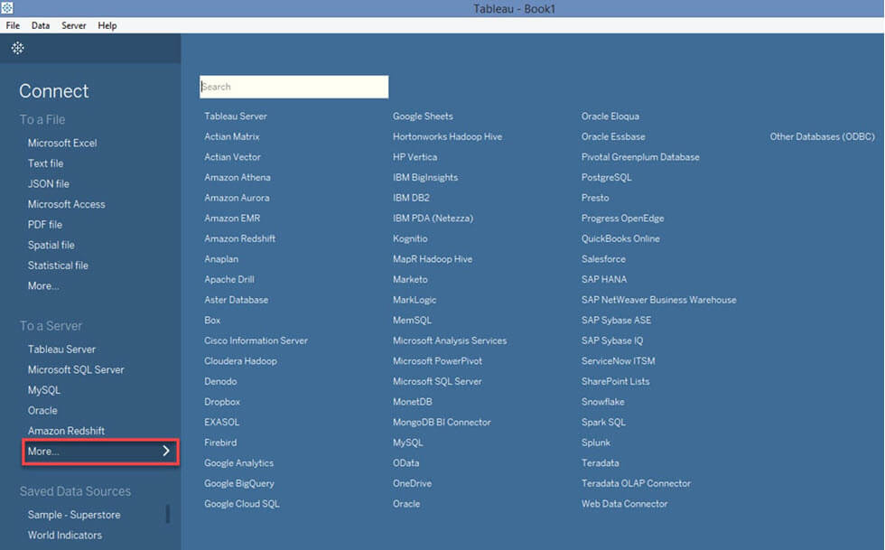

**Connecting to Text File in Tableau**

**Step 1)**Click on the “Text File” option given in the data tab.

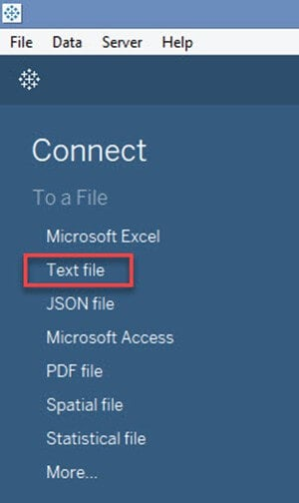

**Step 2)**In the next screen,

1. Select the [SuperStore.csv](https://drive.google.com/uc?export=download&id=1xV_3j-kn7UbHBpLd47DgY5g6obdbmQk1)

2. Click on “Open” Option. This will connect the text file into Tableau.

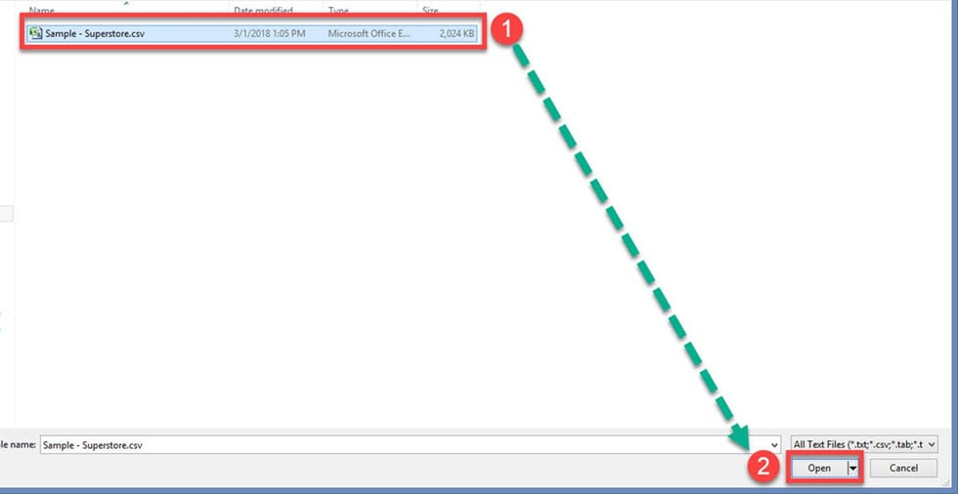

In the left pane you will see the CSV file.

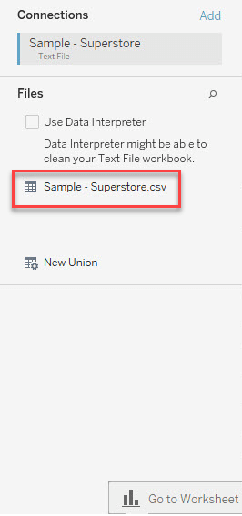

## Connecting to Excel File in Tableau

**Step 1)**Click on the “Microsoft Excel” option given in the data tab.

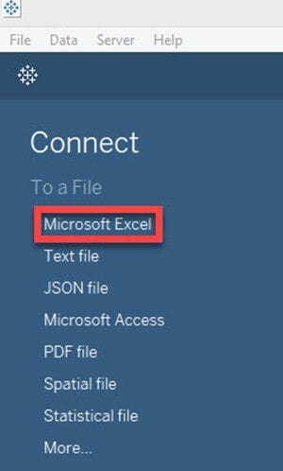

**Step 2)**In the next screen,

1. Select the [SuperStore.xlxs](https://drive.google.com/uc?export=download&id=1wq60dEFV3NUPqpwXaMKtmQPnxzqZHR5F)
2. Click on “Open” Option.

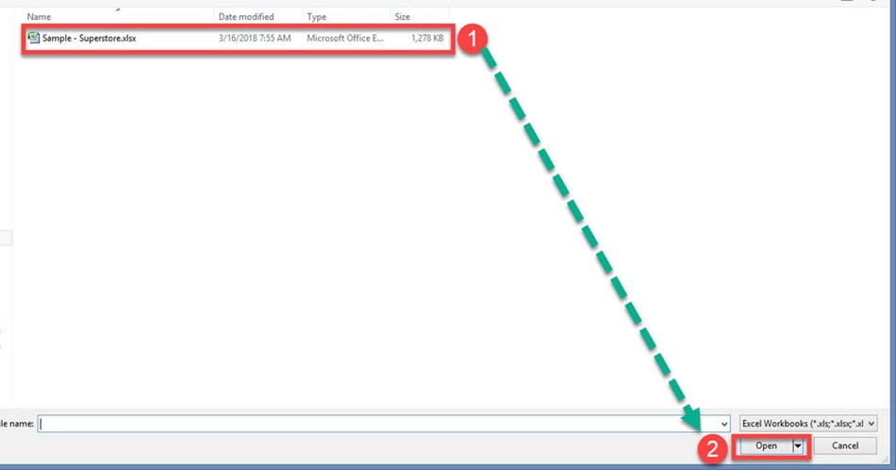

**Step 3)**It connects the excel file into Tableau. The sheets present in the excel file is shown on the left side of the window.

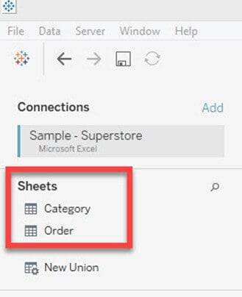

## Connection to Database

**Step 1)** Click on the required database connection given in the data tab. For example, if you want to connect to MySQL database, click on the “MySQL” Option.

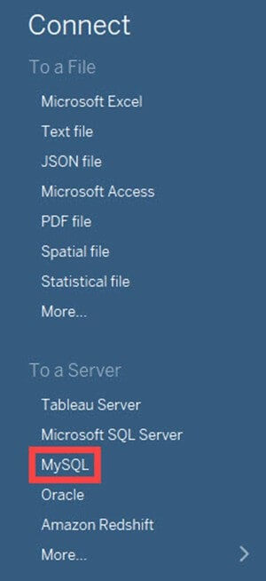

**Step 2)** This will open MySQL connection window.

1. You can enter the MySQL server name and edit the “Port” if needed.
2. Enter the username and password used to connect the database.
3. Click on the “Sign in” button to connect to the database.

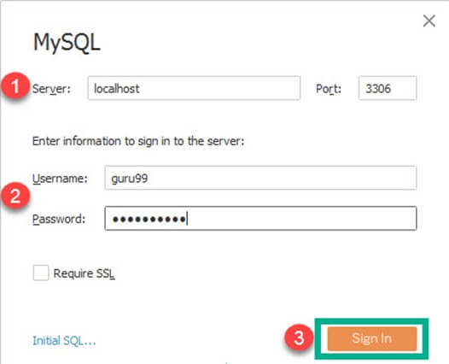

This procedure connects the database into the Tableau. You can select the tables from the database and import it into Tableau. You can join multiple tables by creating a relationship between them.

## Connection to Websites

Tableau can connect to websites using Tableau data connectors. The connection procedure is given as follows.

**Step 1)**In this window,

1. Click on “More” option in the data tab.
2. Select “Web Data Connector” from the list.

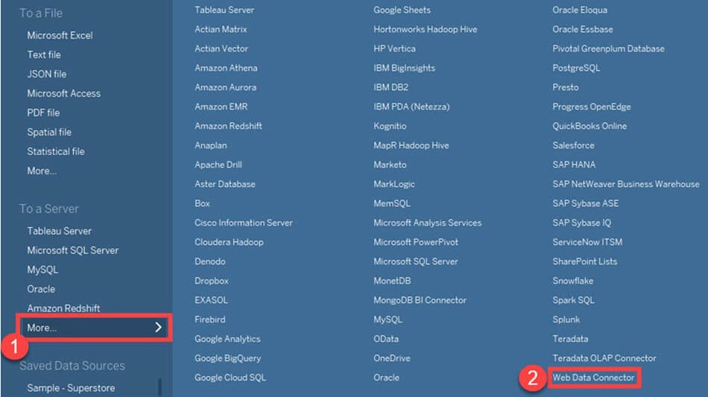

**Step 2)** This will open a Tableau Web Data Connector window where you need to enter the web connector details.

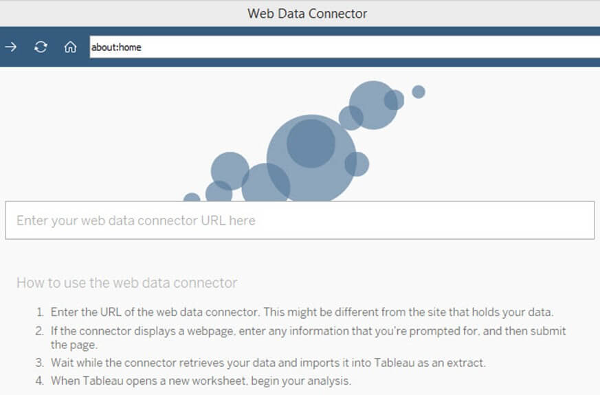

## How to Connect Tableau Desktop to Tableau Server

Tableau Server can store extracted data sources and data connections in Tableau. In enterprise level, it is important to keep all the required data connections in Tableau Server. It helps all the users of the enterprise to connect to the data source easily. The data sets in the Tableau Server can connect to Tableau Desktop by following the given procedures.

**Step 1) Choose Tableau Server from options**

Select the “Tableau Server” option given in the data tab.

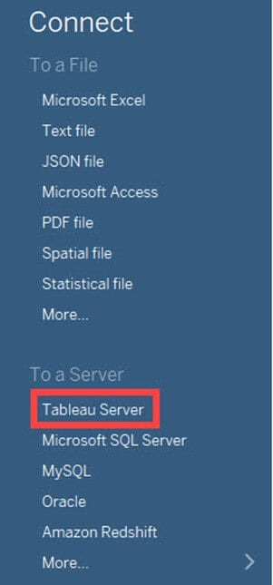

**Step 2) Open the Tableau server**

This opens the Tableau Server Sign in window. Click on ‘Tableau Online’ option.

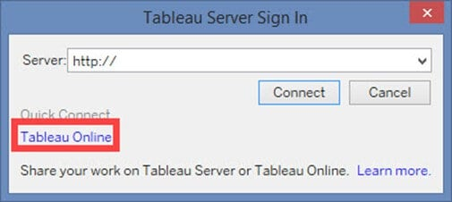

**Step 3) Sign in**

It opens Tableau Online Sign In Window.

1. Enter the registered email id and password.
2. Click on ‘Sign In’ button.

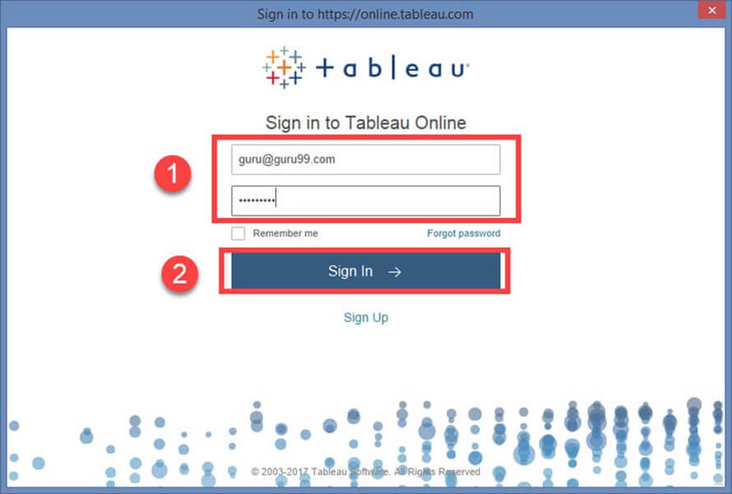

**Step 4) Establish a connection**

This will connect Tableau Server into Tableau Desktop.

1. Select the data set as shown in the figure.
2. This will import the dataset into Tableau.

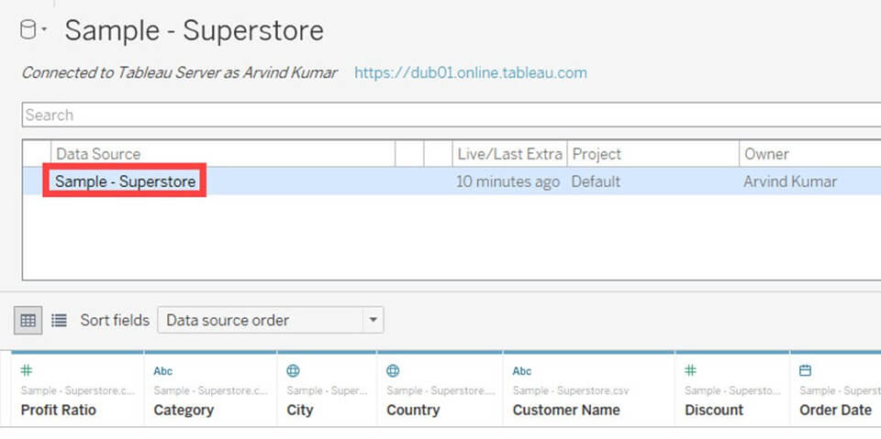

## Data Relationship

A relational Database/Excel file consists of multiple Tables/sheets. These multiple tables/sheets can be connected to each other in Tableau. This connection is established by ‘Join’ or ‘Union’ feature present in Tableau. The relationship between data in two or more tables needs to be specified while joining tables.

### Joins:

Tableau can “join” tables. It can join up to 32 tables in a data source. While joining, the relationship between two or more tables can be specified. The tables present in the data source can be related to each other using the joins such as inner join, left join, right join and outer join. The functionalities of Join types are explained in the table below,

**Step 1)** Once an Excel is connected, Drag the required sheet into data window as shown in the figure.

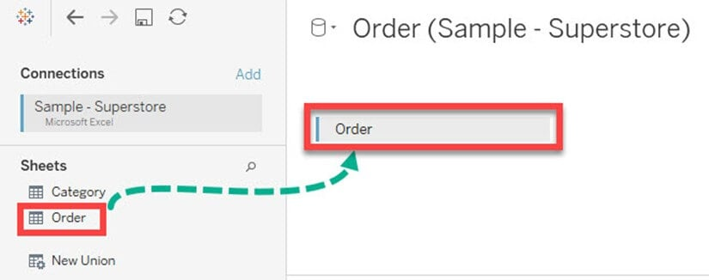

**Step 2)** You can connect multiple sheets by dragging the sheets into the data window. The relationship between the sheets can be given by connecting the data fields.

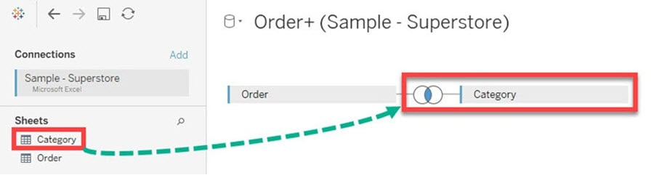

**Step 3)**In the data sheet

1. Click on the “Join” option as shown in the figure. By default, Tableau joins two tables by connecting a relationship between common column present in it.
2. You can edit the relationship by selecting the required joining Condition.
3. You can add one or more data relationship between the sheets or tables.

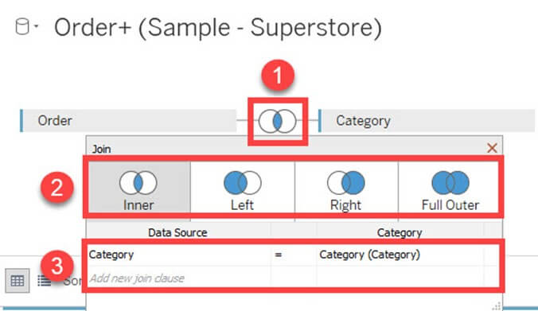

### Union

Union is used to append the data from two or more tables. In most of the cases, tables with same headers are appending together using union function. Joining conditions are not required while union two or more tables. The procedure to union tables are given as follows.

**Step 1)**Drag any of the sheet into data window as shown in the figure.



**Step 2)**Right click on the sheet and select “Covert to Union” option.

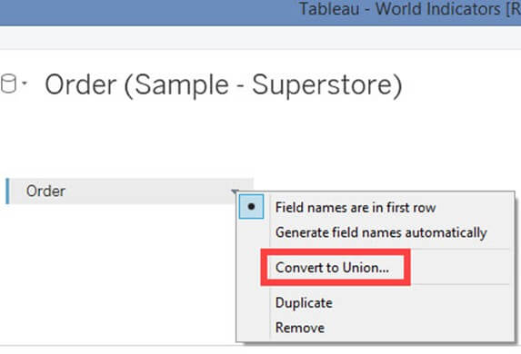

**Step 3)** In the data union window.

1. Drag other sheets which need to be union.
2. Click on ‘OK’ to append or union all the sheets present in the window.

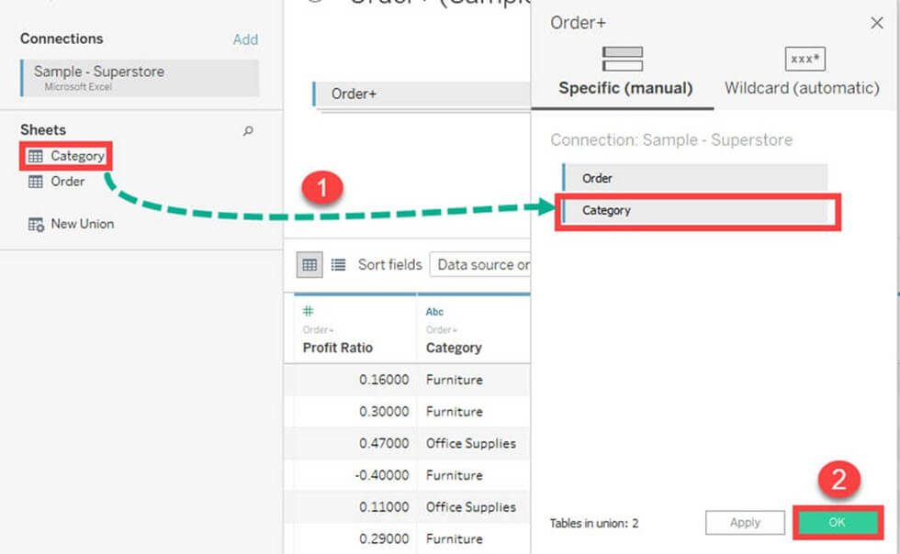

A data relationship is not needed to union sheets present in the data source.

## Data Sorting

Data present in the data source can be sorted based on the user requirement. It can be sorted using data source order, ascending, descending, ascending per table and descending per table.

Once the data is connected to Tableau, data sorting can be done using the “Sort Fields” option. The option is present in the “Data Source” tab.

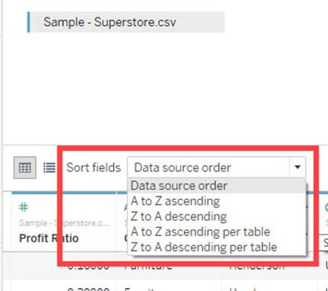

## Replacing Data Source

Tableau can connect multiple data sources in a single workbook. The different Data Sources in Tableau can be used to build various sheets and dashboards. In some cases, data sources need to be replaced with updated file. Tableau has a data source replacing feature which can replace data sources. This feature does not affect the already built visualizations using the old data source. It is important to keep or replace all the used dimensions and measures while replacing the data source.

The data source connected in Tableau can be replaced with another data source. The procedure for replacing data source is given as follows.

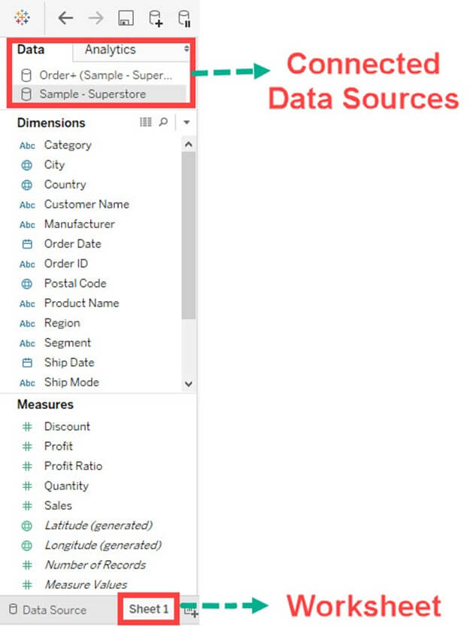

**Step 2)**

1. Select the Data Source to be replaced.
2. Right-click on the data source and select “Replace Data Source” option.

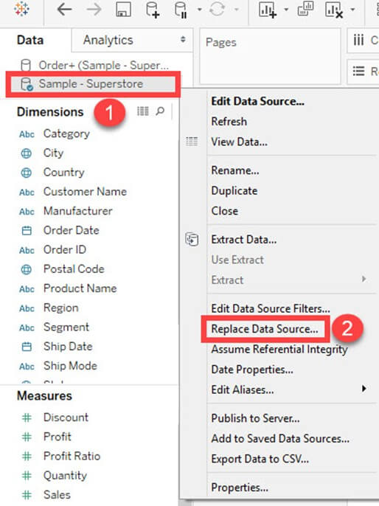

**Step 3)**It opens the data source replacement window.

1. Select the current

2. Select replacement data source.

3. Click on “OK” to replace the data source.

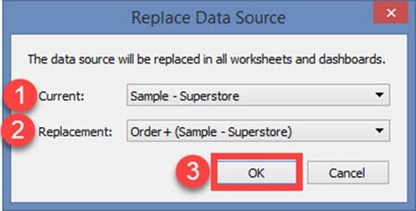

## Summary

* [Tableau](https://www.guru99.com/tableau-tutorial.html) can connect to various data sources like Excel, databases, and websites.
* It can join various sheets or tables present in Tableau data sources.
* The joining conditions used in Tableau are an inner join, right join, left join and outer join.
* Tableau can connect and join various sheets present in an excel file.
* The database can be connected to Tableau by connecting the database server.
* Tableau can connect websites by using web connector.
* Data sorting is available in the Tableau’s data source Tab.
* Tableau Server can be connected to Tableau Desktop.

Data can be organized and simplified by using various techniques in Tableau. We will use the “Sample– Superstore.csv” text file for demonstration in this tutorial.

In this tutorial you will learn

* [Types of Filters:](https://www.guru99.com/filter-data-tableau.html#2)
* [Extract Filters:](https://www.guru99.com/filter-data-tableau.html#3)
* [Filter condition in Tableau](https://www.guru99.com/filter-data-tableau.html#4)
* [Filter Condition by Formula:](https://www.guru99.com/filter-data-tableau.html#5)
* [Data Source Filter:](https://www.guru99.com/filter-data-tableau.html#6)
* [Context Filter:](https://www.guru99.com/filter-data-tableau.html#7)
* [Dimension Filters:](https://www.guru99.com/filter-data-tableau.html#8)

## Types of Filters:

The filters can be applied in a worksheet to restrict the number of records present in a dataset. Various types of filters are used in Tableau Desktop based on different purposes. The different types of filters used in Tableau are given below. The name of filter types are sorted based on the order of execution in Tableau.

1. Extract Filters
2. Data Source Filters
3. Context Filters
4. Dimension Filters
5. Measure Filters

### Extract Filters:

Extract filters are used to filter the extracted data from data source. This filter is utilized only if the user extracts the data from data source.

Once the text file is connected to Tableau, you can see the live and extract option in the top right corner of data source tab. Live Connection directly connects to a data source. Extract connection extracts the data from data source and creates a local copy in Tableau repository. The procedure for creating an extracting filter is given as follows.

**Step 1)** After connecting the text file into Tableau,

* Click on “Extract” radio button as shown in the figure.

This will create a local copy in Tableau repository.

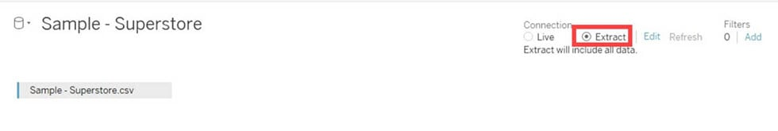

**Step 2)**Next**,**

1. Click on the ‘Edit’ option placed near to Extract button.
2. It opens “Extract data” window. Click on ‘Add’ option present in the Window.

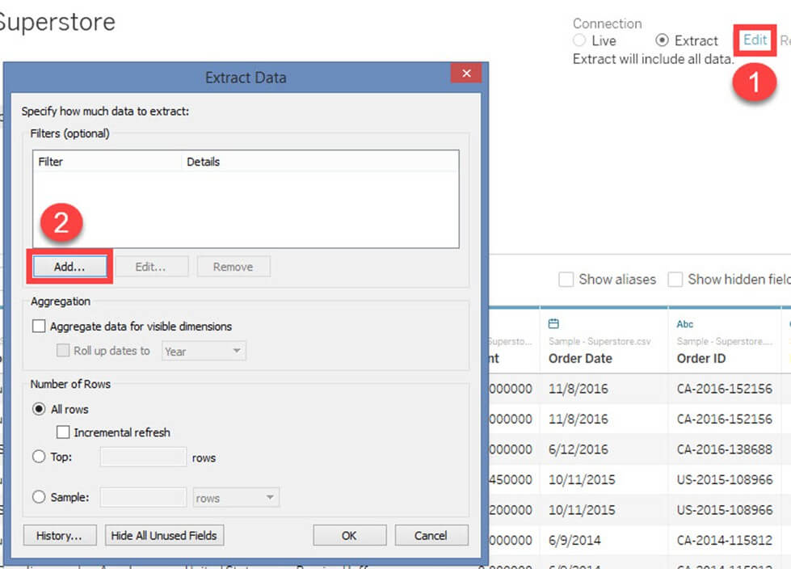

**Step 3)**“Add Filter” Window is open to select the filter conditions.

You can choose any of the fields and add as extract filter. In this example, we have selected’Category’ as extract filter.

1. Select ‘Category’ from the list
2. Click on ‘OK.’

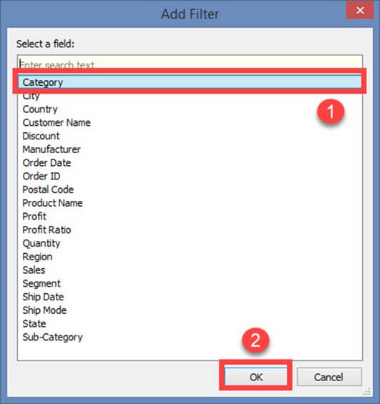

Once you click on OK button, it opens a filter window.

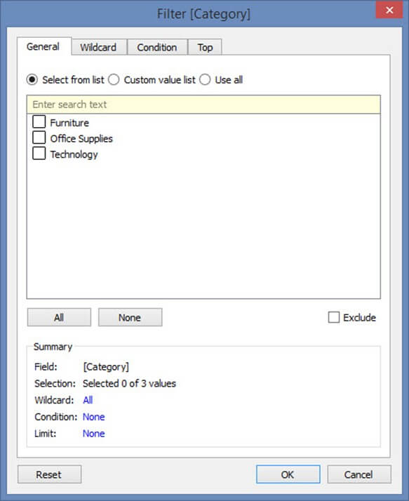

The filter window has multiple options to filter ‘Category’ based on various use case. All the use cases and its filter conditions are explained below.

**Filter condition in Tableau**

**Use Case 1: Select from List**

By default, filter window opens the “Select from List” option. You can include or exclude the members present in the field using this option.

To include you can

1. Select the members
2. Click on OK.

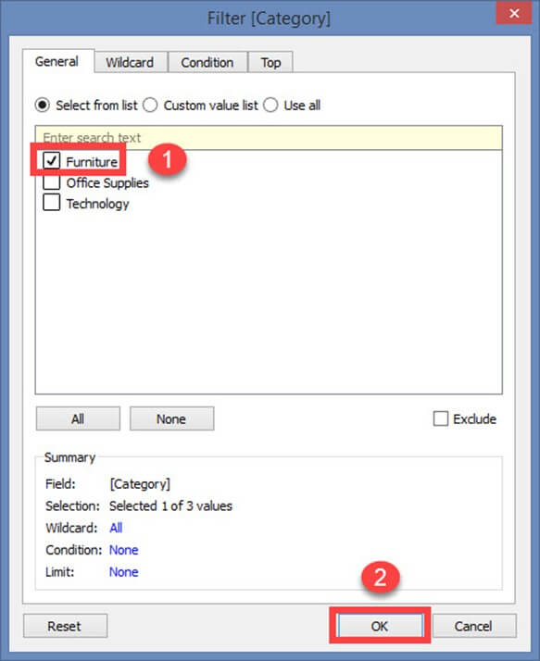

To exclude the selected members,

1. Click on exclude checkbox
2. Select the members to exclude
3. Click on OK.

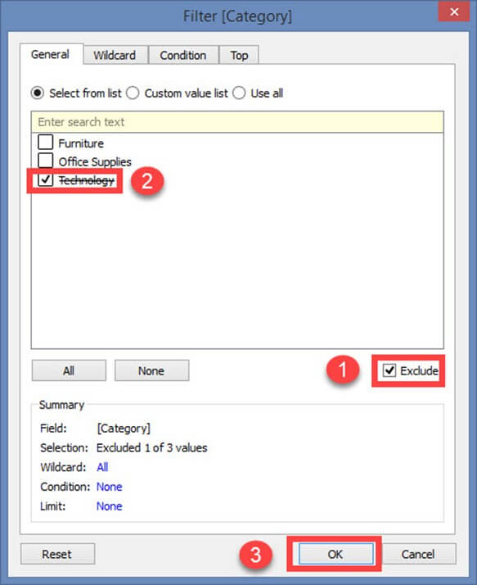

There are two more option in the “Select from List”.

1. All
2. None

**All:**

This option includes or excludes all members present in the field. In this example, all members are included by clicking on “All” option.

**Step 1)**

1. Select ‘All’ option.
2. Click on OK

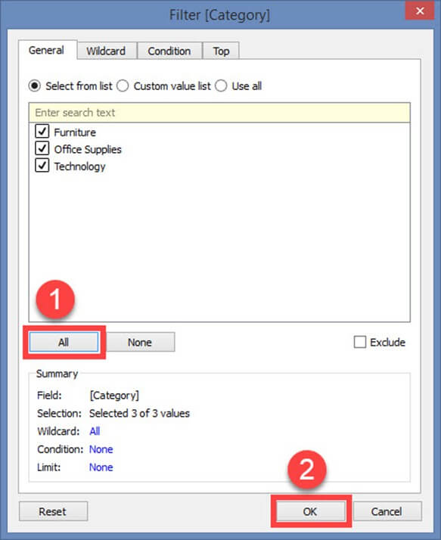

**Step 2)**Next**,**

1. It shows extract data filter. The filter condition is also added in the extract filter window.
2. Click on OK to add the extract filter.

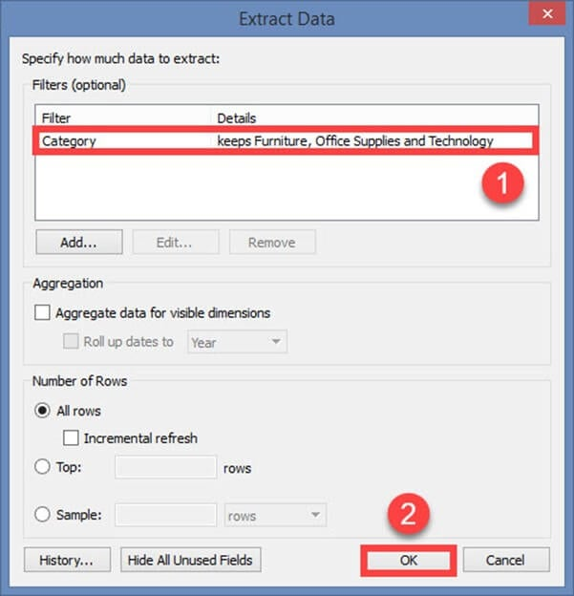

To exclude all the members in the list, first, click on ‘Exclude’ button. Then select ‘All’ option and click on OK. This procedure adds the filter in extract data filter window.

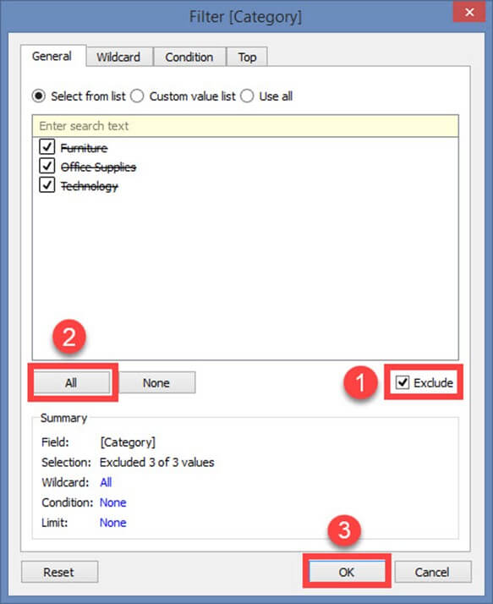

**None:**

If you want clear all the selection made in the filter window and start a new selection, you can use this ‘none’option. None option clears all the selection made in the filter window. Once it is cleared you can select the new members.

1. Click on the ‘None’ option. Select the new members to be added as filter.
2. Click on OK to add the extract filter.

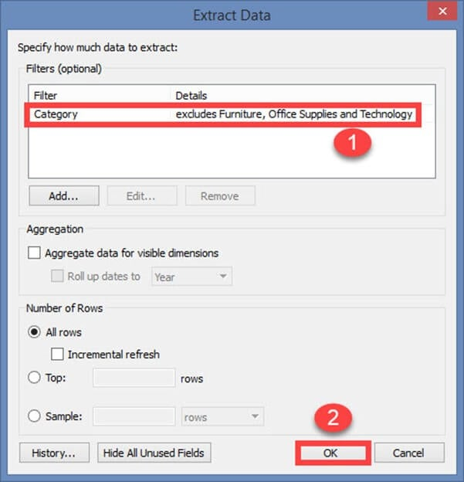

**Use Case 2: Custom Value List**

A custom value list allows the user to type the member name and filter the field accordingly. A custom value list can be created by following the given procedure.

**Step 1)**In the Filter Screen

1. Click on “Custom value list” radio button.
2. Type the member name.
3. Click on ‘+’ symbol to add the name in the list.
4. You can add multiple members in the list and click on OK

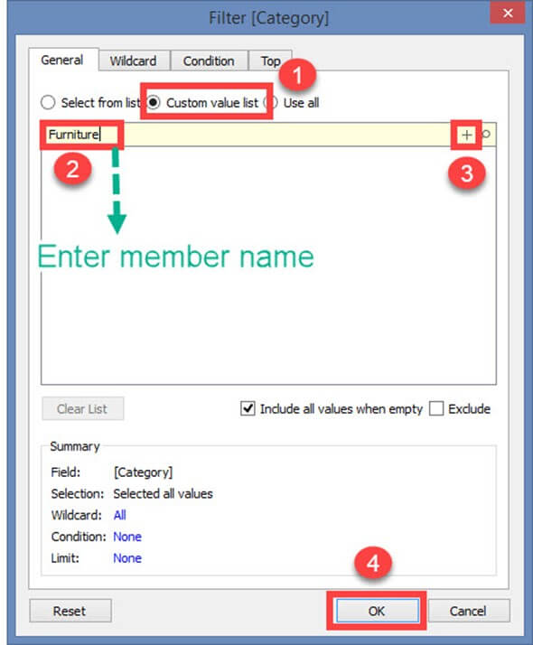

There is an option in the window “Include all values when empty.” It can be selected to include all values present in the field when the selected member has no data.

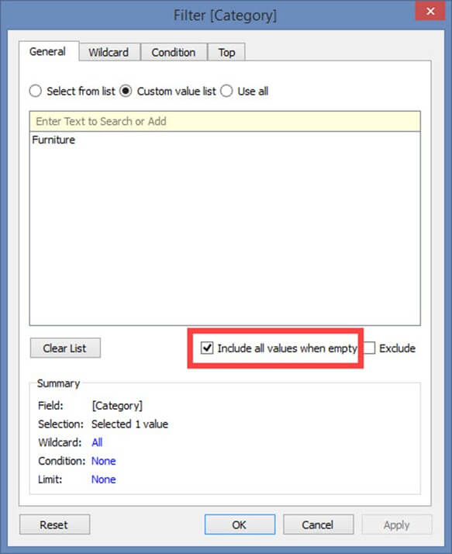

Clear List option clears the customs value list.

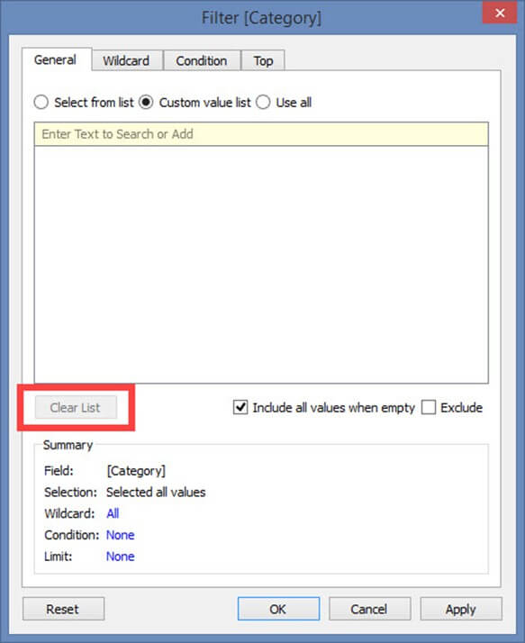

**Use Case 3: Use all**

This option selects all the members present in the field.

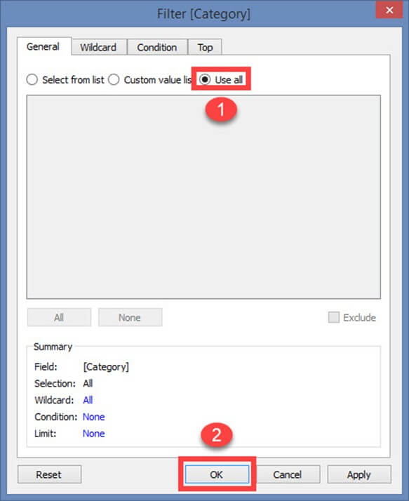

**Use case 4: Wildcard**

Wildcard option is used to filter the fields based on given wildcard match. Users can type the character and filter the field based on the match. The different types of matches are given as follows.

|  |  |
| --- | --- |
| **Contains** | Select the members if the member name contains typed characters. |
| **Starts with** | Select the members if the member name starts with typed characters. |
| **Ends with** | Select the members if the member name ends with typed characters. |
| **Exactly matches** | Select the members if the member name exactly matches with typed characters. |

**Step 1)**

1. Select the “Wildcard” tab.
2. Type the characters to match.
3. Select the type of match. In this example “Contains” match type is selected.
4. Click on OK.

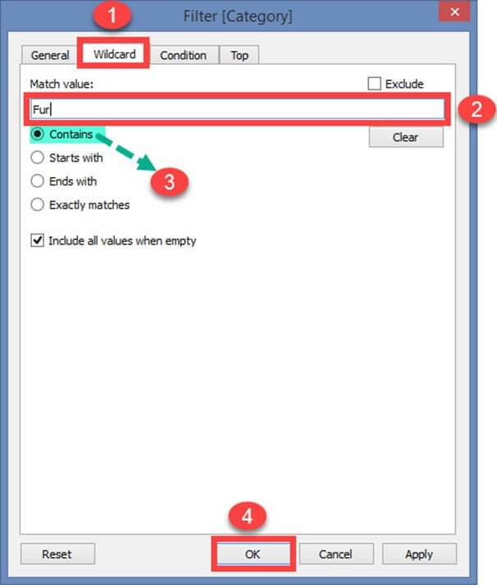

**Use Case 5: Filter on Condition**

This option is used to filter the data set by giving several conditions. Filer condition based on field is given below.

**By Field:**

1. Select the ‘Condition’ tab in Filter Window.
2. Click on radio button ‘By field.’
3. Select the name of the field to be filtered from the drop-down list.
4. Select the aggregation type like Sum, average and median from the drop-down list.
5. Choose the operator from the drop-down.
6. Enter the value to filter the selected field.
7. Click on OK.

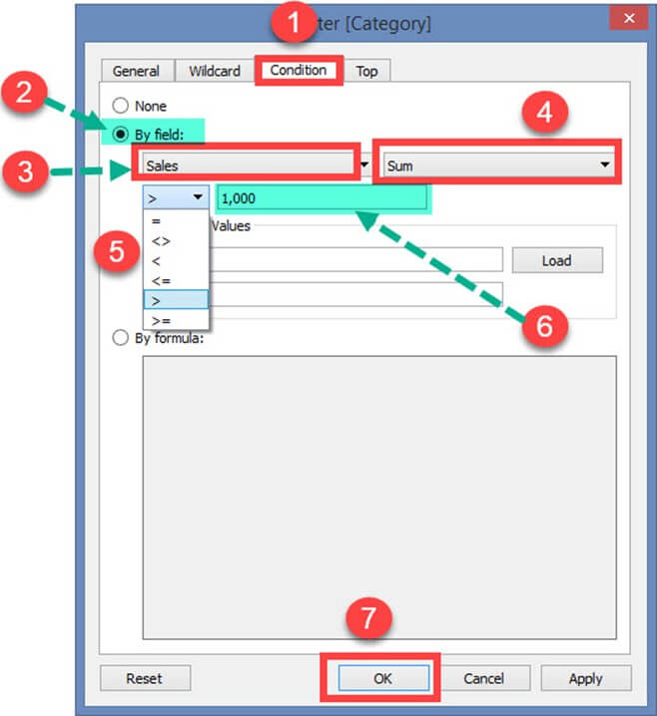

In the above example, the dataset is filtered to see the data where the sum of sales is greater than 1000.

**The range of Values:**

This option shows the minimum and maximum value of the selected field by clicking on ‘Load’ button. It can be used to refer the values.

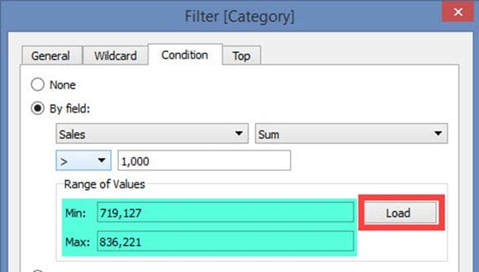

**Filter Condition by Formula:**

You can write a formula to filter the dataset using this option. The procedure is explained below.

**Steps:**

1. Click on radio button ‘By formula.’
2. Enter the formula in the box as shown in the figure.
3. Click on Ok.

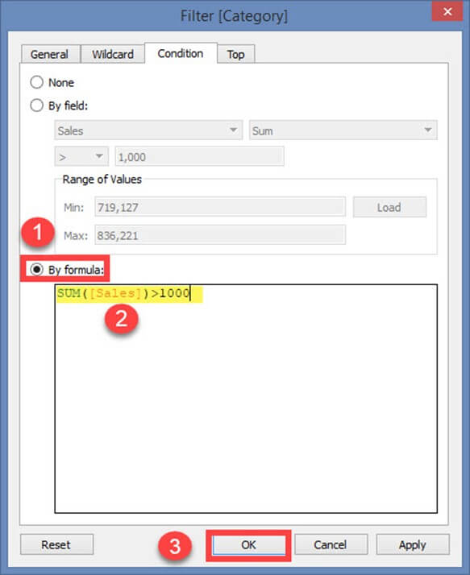

In the above example, the written formula filters the data where sum of sales is greater than 1000.

**Use Case 6: Top or bottom filters**

This option is used to select top or bottom ‘n’ number of records.

**By Field:**

**Step 1)**

1. Select ‘Top’ tab from the filter window.
2. Click on radio button ‘By field’.

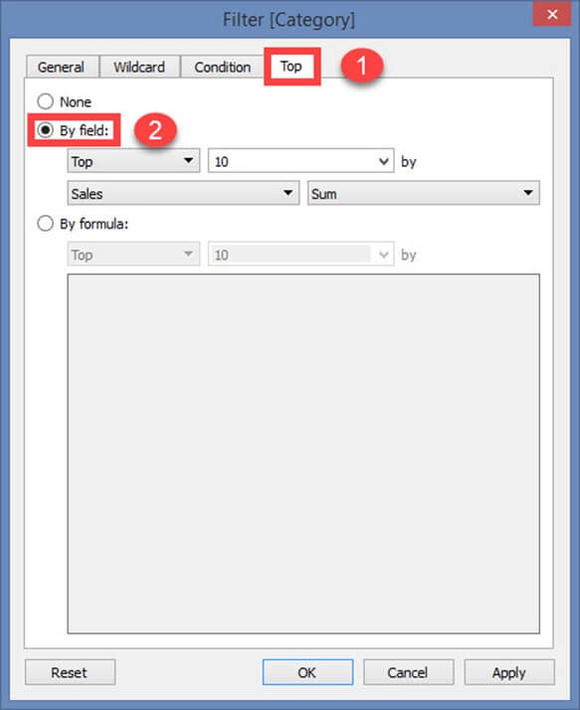

**Step 2)**

1. Select ‘Top’ or ‘Bottom’.
2. Choose the number of records.
3. Select the field.
4. Choose the aggregation type.
5. Click on Ok.

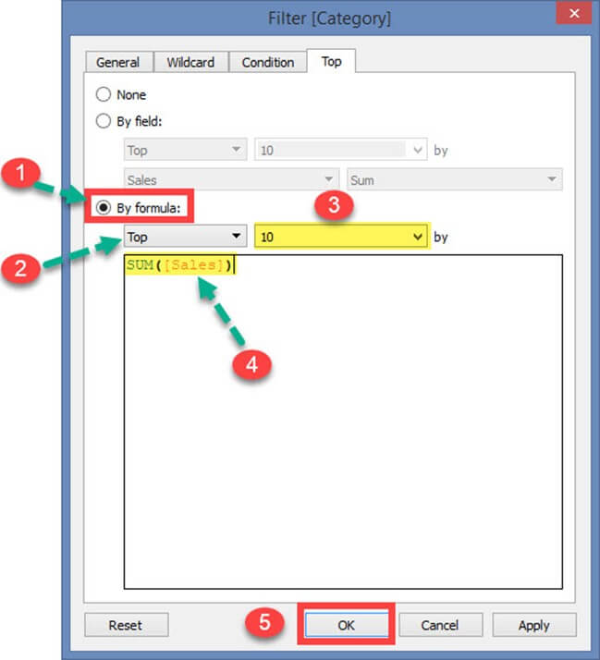

In the above example, the formula was written to show top 10 records based on the sum of sales.

### Data Source Filter:

A data source filter is used to filter the data in data source level. It can restrict the records present in the data set. This filter is similar to extract filter on securing the data. But data source filter and extract filter is not linked to each other. **Data source filter works on both live and extracts connection**. The procedure to select data source filter is given as follows.

**Step 1)**Click on the ‘Add’ button placed on the top right corner of the data source tab.

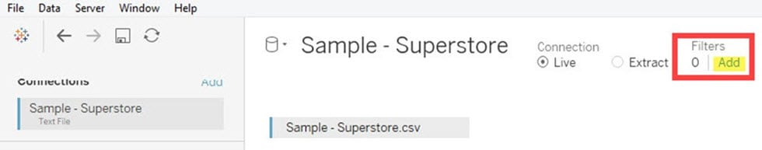

**Step 2)** It opens the ‘Edit Data Source Filters’ Window. Click on ‘Add’ Option present in the window.

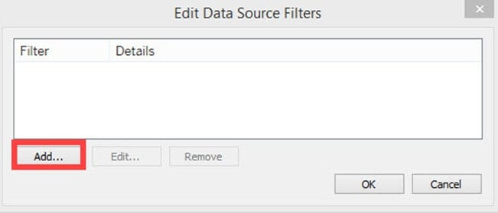

After clicking on ‘add’ button, follow the remaining steps from the topic ‘Extract Filters’ -> Step 3.

### Context Filter:

A Context filter is an independent filter that can create a separate dataset out of the original data set and compute the selections made in the worksheet. One or more categorical filter that separates the dataset into major parts can be used as a context filter. All other filters used in the worksheet works based on the selection of context filter. The functions of context filters can be explained through an excel sheet.

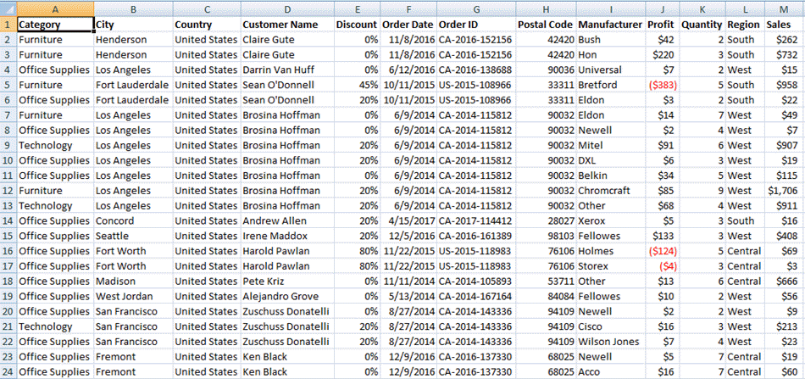

The figure shows a sample dataset. From the dataset, it is identified that ‘Category’ can be used as context filter as it can divide the dataset into major parts. Once the filter is applied to the dataset, the following data can be obtained.

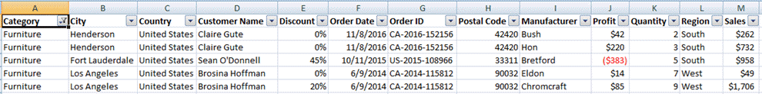

When the category “Furniture” is selected, the data available in the particular category is shown in the figure. Other filters that can be applied in the sheet will be dependent on the category filter. This is the basic function of using context filter. Tableau creates a temporary dataset in repository engine based on the context filter selection. Once context filter is selected, all other selections and filters depend on the selection of specific context filter. The temporary table or data set that is created on selecting context filter loads whenever the context filter is changed.

**Apply Context Filters in Worksheet:**

Any dimension can be added as context filter by following the steps given below:

**Step 1)** The dimension to be added as context filter needs to be added in filter section box as given in the image.

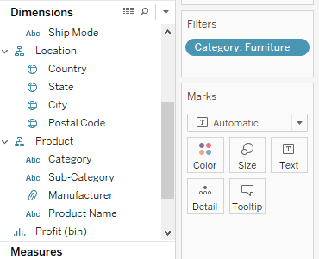

**Step 2)** Right click on the dimension added in the filter section and select “Add to Context” option.

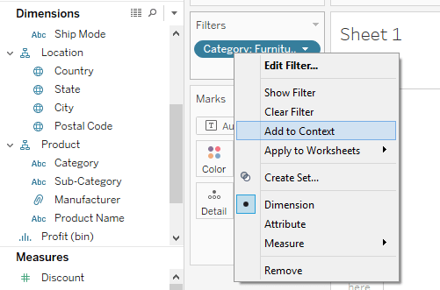

**Step 3)** Once the filter is selected as a context filter, the color of dimension box changes to grey color. This grey color box is an indication of context filter.

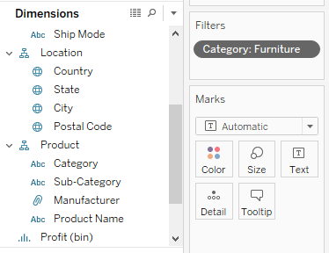

**Removing Context Filter:**

Any context filter can be changed back to normal filter by selecting the “Remove from Context” option which is available when right-clicking on the dimension. The color of dimension box will also change back to blue color as an indication.

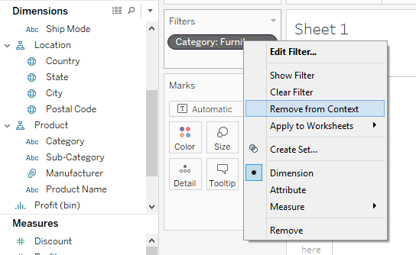

**Advantages of Using Context Filters:**

**Improve Performance:**

When context filter is used in large data sources, it can improve the performance as it creates a temporary dataset part based on the context filter selection. The performance can be effectively improved through the selection of major categorical context filters.

**Dependent Filter Conditions:**

Context filters can be used to create dependent filter conditions based on the business requirement. When the data source size is large, context filter can be selected on the major category, and other relevant filters can be executed.

### Dimension Filters:

When a dimension is used to filter the data in a worksheet, it is called as Dimension filter. It is a non-aggregated filter where a dimension, group, sets and bin can be added. A dimension filter can be applied through the top or bottom conditions, wildcard match and formula.

The members present in a dimension can be included or excluded from the list using this filter. Dimension filter can be shown in a sheet or dashboard to change the filter condition dynamically. The process for adding a dimension as the filter is given as follows.

**Step 1)** Go to a worksheet as given in above topics and follow the steps.

1. Select a dimension from the dimension list. In this example ‘Category’ is chosen from the dimension list. Drag the dimension into ‘Filters’ box.
2. It opens the ‘Filter’ Window. Select the member from the list.
3. Click on OK.

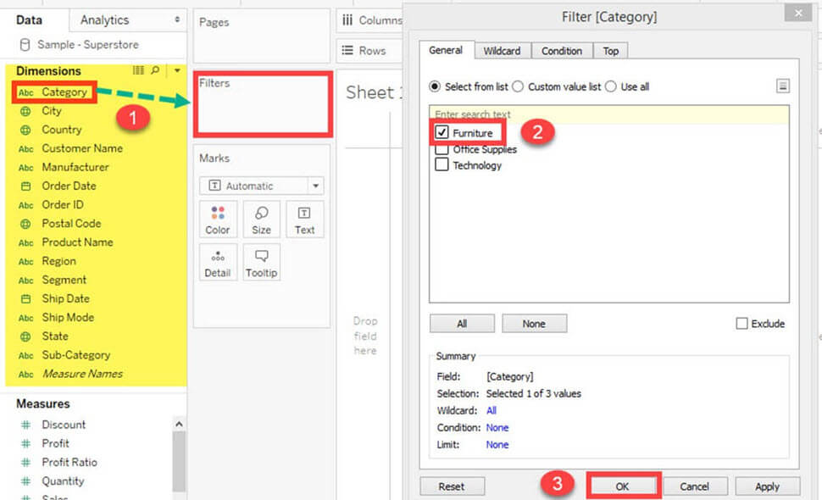

The above procedure filters data set to show the records only for category ‘Furniture.’

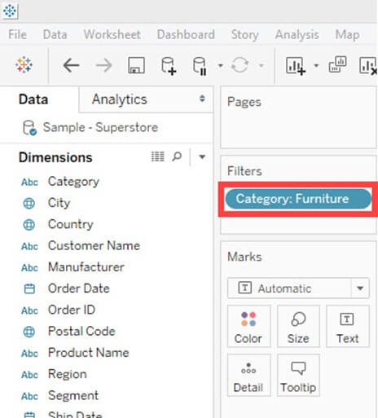

**Measure Filter:**

A measure filter can filter the data based on the values present in a measure. The aggregated measure values can be used in measure filter to modify the data. A measure filter can be applied in a worksheet by following the procedure.

**Step 1)**Go to a Worksheet

1. Select a measure present in the Measures tab. In this example, ‘Sales’ is selected. Drag the measure into ‘Filter’ box.
2. It opens a ‘Filter field’ window. Select any of the aggregation from the list. In this example, Sum is taken as aggregation type.
3. Click on ‘Next’ button.

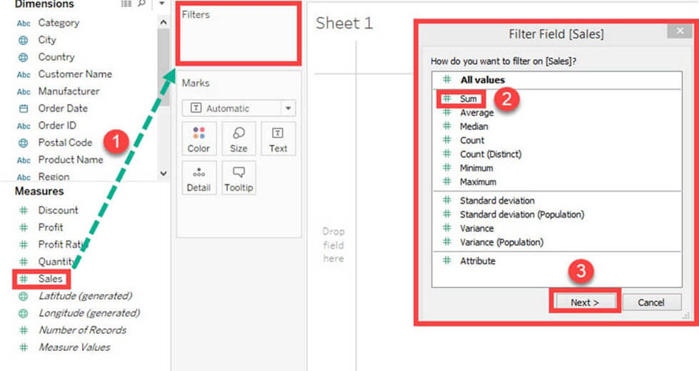

**Step 2)** It opens a window where you need to select the range of values. The other types of options present in the window are given as follows.

|  |  |
| --- | --- |
| **Range of values** | Minimum and maximum range of measure value can be given and filtered. |
| **At least** | A minimum value of a measure is given to filter the data. |
| **At most** | A maximum value of a measure is given to filter the data. |
| **Special** | An option to select null or non-null values and filter the data. |

1. Select the range of values. You can modify the upper and lower limit for the range of values.
2. Click on OK.

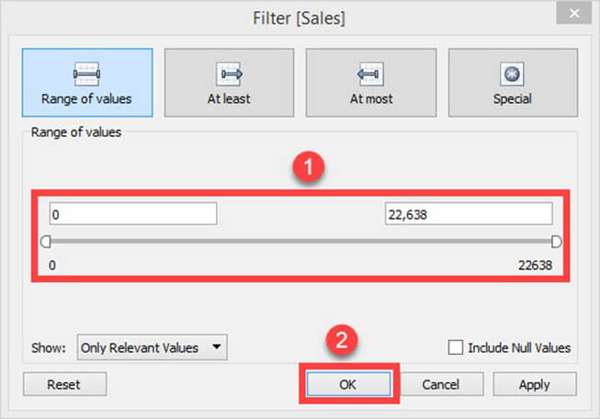

The above example filters the data set based on the sum of sales value between 0 and 22638.

**Custom or Quick Filter:**

Filters can be customized based on the user selection. The filters can customize worksheets and dashboards to modify the data dynamically. The procedure to customize the filter is given as follows.

**Step 1)** Add the ‘Category ‘filter as shown in the topic Dimension filter.

1. Right-click on the filter added.
2. Select ‘Show Filter’ option.

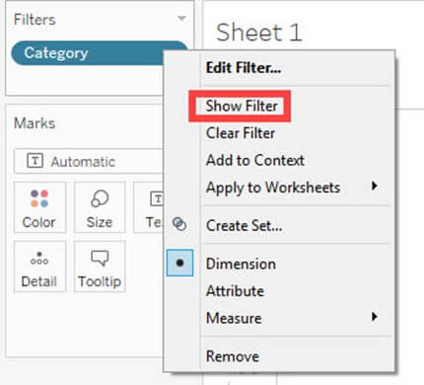

**Step 2)** It shows the ‘Category’ filter box in the right side of the worksheet. By default, the filter shows the multi-value list as shown in the figure.

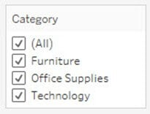

**Step 3)** You can select or unselect members present in the filter and modify the data.

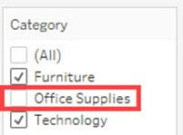

**User Filter:**

User filter secure the row level data present in a dataset. It can be used when publishing the workbook on a server. Different filter conditions can be applied for different users. For example, assume there are three departments in a firm namely Furniture, Office Supplies, and Technology. By using the user filter, we can allow the users to show only the data relevant to their department. i.e., Users from ‘Furniture’ department can only see the data from category ‘Furniture’. This can assure the security of row level data. The procedure to apply the user filter is given as follows.

**Step 1)**

1. Click on the Server option present in the Menu bar.
2. Hover over the ‘Create User Filter’ option.
3. Select the field to create user filter. In this example, the category is selected as user filter.

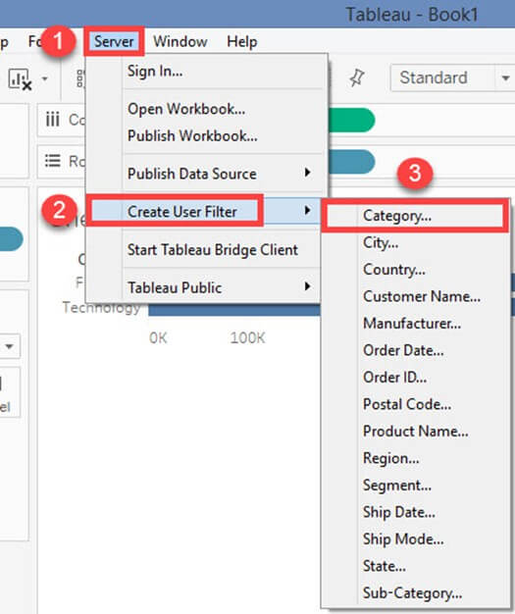

**Step 2)**

1. It opens a ‘Tableau Server Sign in’ window.
2. Click on ‘Tableau Online’ option present in the window.



**Step 3)**

1. It opens a Tableau Online Sign in Window. Enter your registered email id and password.
2. Click on Sign In option.

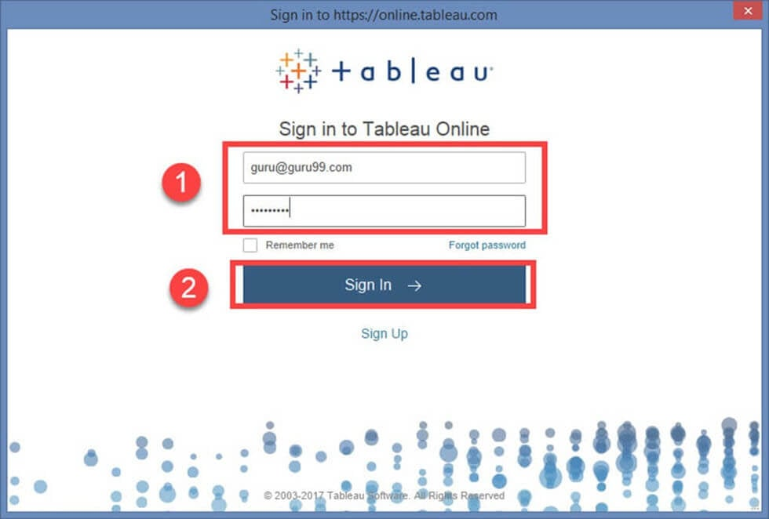

**Step 4)**It opens a ‘User Filter’ window. Follow the below steps to add user filter.

1. Enter a name for the user filter.
2. Select a user form the user’s list.
3. Check in the required members need to show for the selected member.
4. Click on OK.

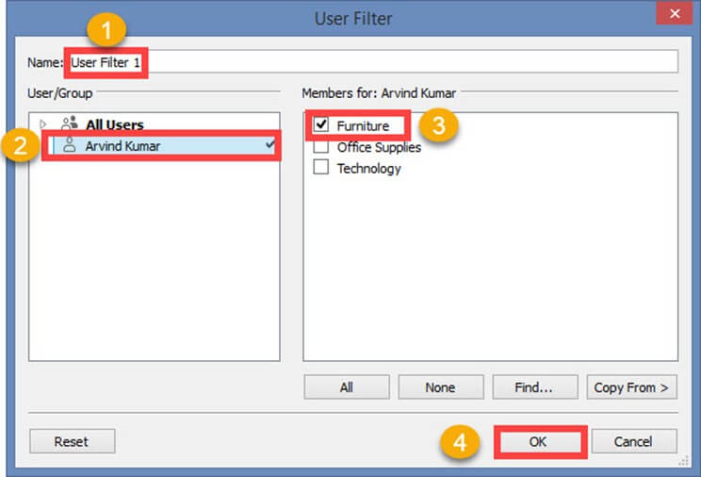

It creates a user filter in Tableau. You can view the user filter under sets pane as shown below.

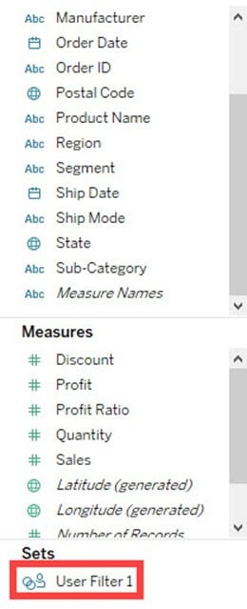

When the workbook is published in the server, only the filtered data is shown to the user. User filter can be created for multiple users to secure the data.

**Summary:**

* Tableau has features to organize and simplify the data present in the data set.
* Filter restricts the number of records present in data set based on given condition.
* Various types of filters used in Tableau are extract filters, data source filters, context filters, dimension filters and measure filters.
* Extract filters modify the data in the local copy of data set which is extracted from the data source.
* Data source filters modify the data based on given condition. These filters apply on both live and extract connection.
* Context filter creates a temporary table in Tableau engine and acts as a primary filter. All the other filters applied on a worksheet depend on the Context filter.
* When a dimension is used to filter the data, it is called as dimension filter. It can include or exclude the members present in the dimension.
* When a measure is used to filter the data, it is called as measure filter. It can modify the data based on the comparison of measured value.
* A quick or custom filter is used to modify the filter condition dynamically.
* User filters secure the row level data published in a server.
* Users can sort the fields present in the data set.
* Groups can be building to group the members present in a dimension.
* Users can build hierarchy to show the granularity level present in the dataset.
* Sets can be created to select or exclude one or more members from a field. A set can be added as a separate dimension in Tableau.

# Tableau Charts & Graphs Tutorial: Types & Examples

[Tableau](https://www.guru99.com/tableau-tutorial.html) can create interactive visualizations customized for the target audience. In this tutorial, you will learn about the measures, chart types, and their features.

In this tutorial, ‘Sample-Superstore.csv’ is used for the demonstration. You can connect to the data source and follow the steps given in the tutorial.

* [Measure names and Measure values](https://www.guru99.com/tableau-charts-graphs-tutorial.html#1)
* [Generated Fields](https://www.guru99.com/tableau-charts-graphs-tutorial.html#2)
* [Understand how and when to build different types of Visuals](https://www.guru99.com/tableau-charts-graphs-tutorial.html#3)
* [Pareto Chart](https://www.guru99.com/tableau-charts-graphs-tutorial.html#4)
* [Bullet Chart](https://www.guru99.com/tableau-charts-graphs-tutorial.html#5)
* [Bar Chart](https://www.guru99.com/tableau-charts-graphs-tutorial.html#6)
* [Line chart](https://www.guru99.com/tableau-charts-graphs-tutorial.html#7)
* [Text Tables](https://www.guru99.com/tableau-charts-graphs-tutorial.html#8)
* [Heat Map](https://www.guru99.com/tableau-charts-graphs-tutorial.html#9)
* [Waterfall Chart](https://www.guru99.com/tableau-charts-graphs-tutorial.html#10)
* [Gantt chart](https://www.guru99.com/tableau-charts-graphs-tutorial.html#11)
* [Pie Chart](https://www.guru99.com/tableau-charts-graphs-tutorial.html#12)
* [Scatter Plot](https://www.guru99.com/tableau-charts-graphs-tutorial.html#13)
* [Area Chart](https://www.guru99.com/tableau-charts-graphs-tutorial.html#14)
* [Dual Axis Chart](https://www.guru99.com/tableau-charts-graphs-tutorial.html#15)
* [Bubble Chart](https://www.guru99.com/tableau-charts-graphs-tutorial.html#16)
* [Histogram](https://www.guru99.com/tableau-charts-graphs-tutorial.html#17)

## Measure names and Measure values:

Measure names and Measure values are the two fields created in Tableau by default. These fields are created when a data set is imported into Tableau. You can go to a Data pane of the worksheet and view the fields as shown in the figure.

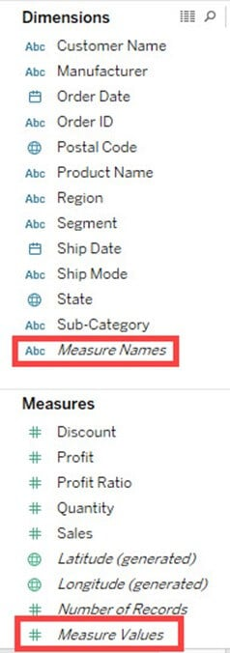

**Measure Names:**

A measure name consists of all the names of the measure present in a data set. It always presents at the end of dimension list. It consists of discrete values of all measure names.

**Measure Values:**

All the measure values present in a data set are kept together in the field called measure values. It always presents at the end of measures list. It consists of continuous values of all measures.

**Use cases of Measure Names and Measure Values:**

**Case 1:**

Measure names and Measure values can be used to see the aggregation of all measure present in a data set. These fields can be shown as different types of visualization in Tableau.

**Steps:**

1. Drag ‘Measure Names’ into Columns.
2. Drag ‘Measure Values’ into Rows.

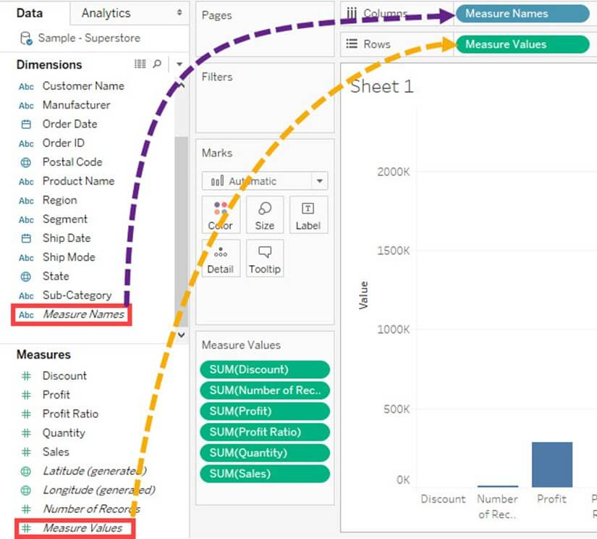

It creates a visual for all measures present in the data set. By default, Tableau creates a **bar chart** showing all the measure names and their values.

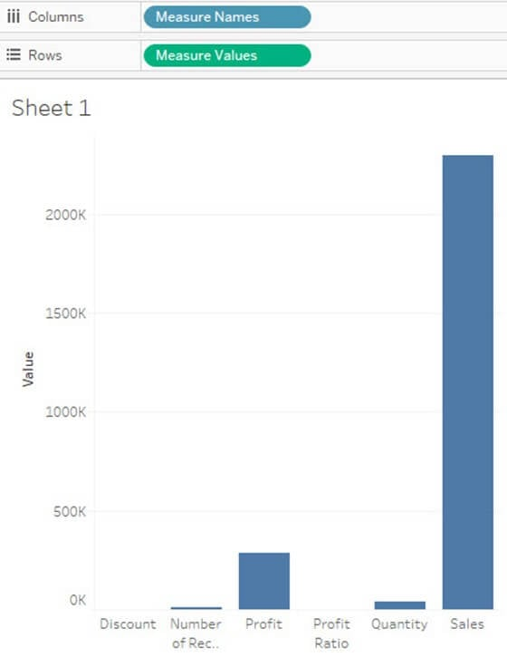

**Case 2:**

Any measures can be removed from the visual by removing the measure from mark card. It can be removed by

1. Right-click on a measure name.
2. Click on ‘Remove’ option.

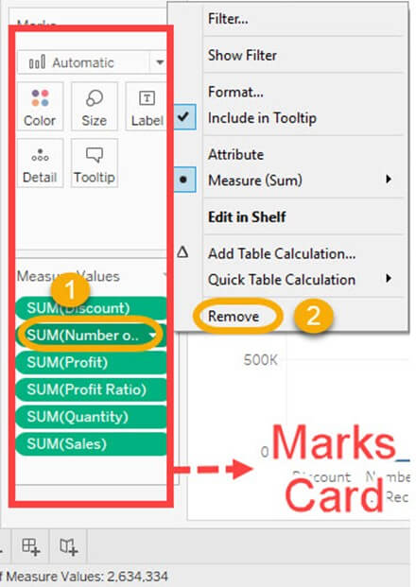

It removes the measure from the visualization.

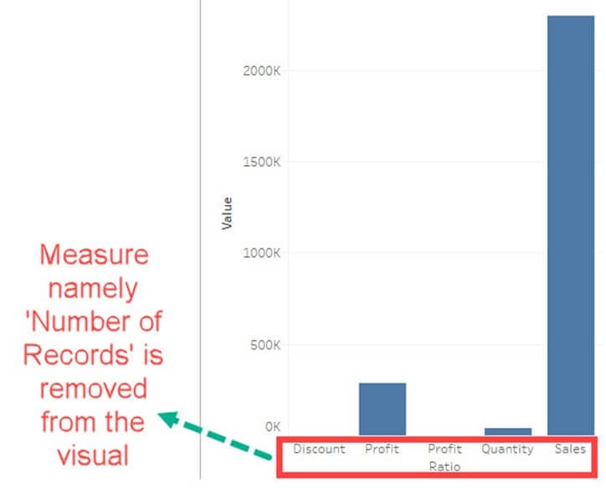

**Case 3:**

Alias name can be created for measure names. It can be shown in the visualization for better identification.

**Step 1)**Use the same steps given in case 2 and follow the below steps.

1. Right click on measure name present in Columns.
2. Select the ‘Edit Alias’ option in the list.

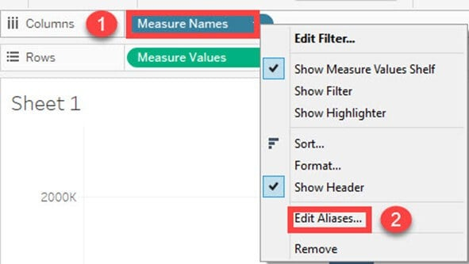

**Step 2)**It opens ‘Edit Aliases’ Window.

1. Edit the alias name for the member. In this example, ‘Volume Sales’ is given as alias name for ‘Quantity’.
2. Click on OK.

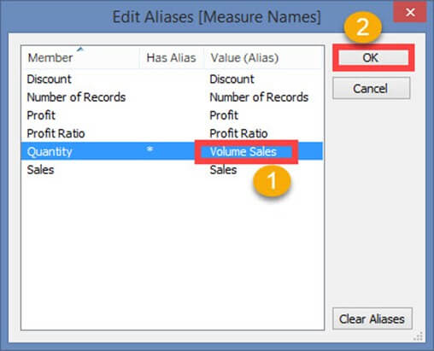

You can see the name change in Visualization.

**Case 4:**

If you want to analyze multiple measures in a single visual, it can be done by using measure names and measure values.

In this example, we will see the trend of measures namely sales, profit and quantity over the years.

**Step 1)**

1. Drag measure values into the filter box.
2. It opens a filter window.
3. Check out all the measures except Profit, Quantity, and Sales.
4. Click on OK button.

It adds the measure name filter in the filter box.

**For example**The above filter condition shows the visual as follows:

It creates a filter on selected measures in the worksheet.

**Step 2)**

1. Drag ‘Order Date’ into Columns.
2. Drag ‘Measure Values’ into Rows.

**Step 3)**

1. Drag Measure Names into ‘Color’ option present in the marks card.
2. It creates color of the visual based on the measure name. It also specifies different color to different measure names present in the visual.
3. A line chart is generated for multiple measures over years as shown in the figure.

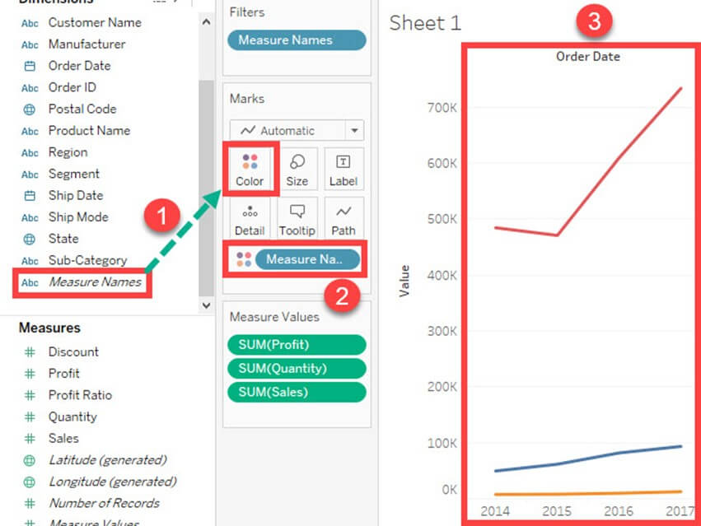

## Generated Fields:

Tableau generates some fields which can be visible in the data pane. These fields are generated in addition to the fields present in the data set. The generated fields are given as follows.

* Measure Names
* Measure Values
* Number of Records
* Longitude
* Latitude

Measure Names and Measure Values are already explained in the article.

**Number of Records:**

Number of records shows the count of records present in the data set. It is an auto-generated field in Tableau which assigns a value ‘1’ for each record present in the data set. It can be used to verify the count of records when joining multiple tables. The procedure to check the number of records present in a dataset is given as follows.

**Step 1)**Go to a Worksheet

1. Drag ‘Number of Records’ present in measure pane into Rows.
2. It creates a bar chart by default. Hover over the bar to see the number of records present in the data set.

**Longitude and Latitude:**

Longitude and Latitude (generated) fields are associated with the geographical detail present in the data. Dataset should consist of geographical details like City, Country or State. The longitude and latitude values are auto-generated in Tableau. These fields can be used to build maps in Tableau. You can create geographical maps using Longitude and Latitude is given as follows.

**Step 1)** Drag Longitude (generated) into columns and Latitude (generated) into Rows.

**Step 2)** Drag ‘State’ from Dimension list into ‘Detail’ present in Marks Card.

This creates a geo-mapping visual as shown below.

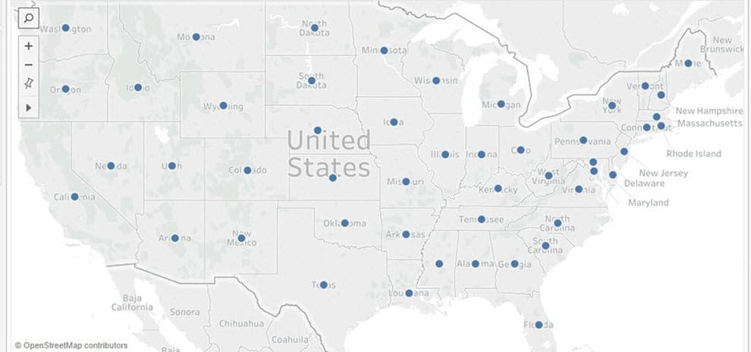

## Understand how and when to build different types of Visuals:

Tableau can create interactive visuals for easy data interpretation. You can create various types of graphs in Tableau based on the purpose. The different charts that can be created using Tableau and their purpose are given as follows.

## How to create Pareto Chart

A Pareto chart consists of both bar and line graph. The same measure is used to create the graphs but the measure values are manipulated differently. The purpose of using Pareto Chart in Tableau is to identify the contribution of members present in a field. For example, Profit contributed by different subcategory of products in a retail store can be analyzed using Pareto Chart. It can show the top members and their contribution. The procedure to create a Pareto Chart is given as follows.

**Step 1)**Go to a new Worksheet.

1. Drag ‘Sub-Category’ into Columns.
2. Drag ‘Profit’ into Rows.

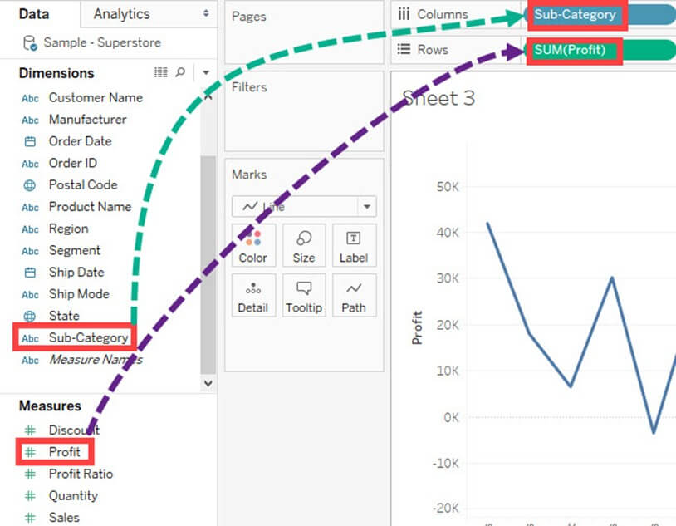

**Step 2)**Right click on ‘Sub-Category’.

1. Select ‘Sort’ option from the list.

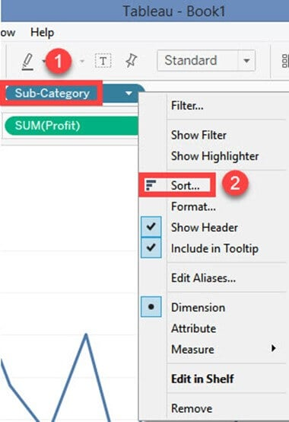

**Step 3)**It opens a Sort Window.

1. Click on ‘Descending’ in Sort order.
2. Select ‘Field’ in ‘Sort by” section. Select the field as Profit and choose ‘Sum’ as aggregation.
3. Click on OK.

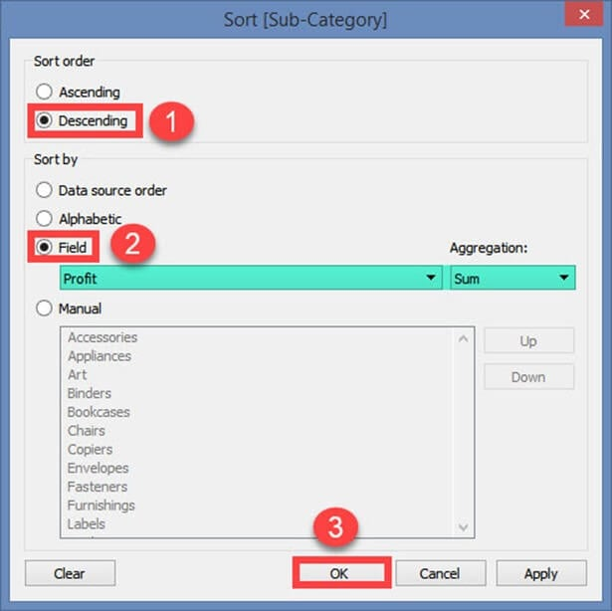

**Step 4)** Drag ‘Profit’ again into Rows.

1. Right-click on the newly added ‘Profit’ and Select ‘Dual axis’ option.

It merges the x-axis of both measures and converts the visualization as given below.

**Step 5)**Go to Marks Card.

1. Select ‘SUM(Profit)’ for the marks card list.
2. Click on the drop-down button as shown in the image.
3. Select ‘Bar’ as chart type.

**Step 6)**Select ‘SUM(Profit)(2)’ from the marks card list.

1. Select the drop-down button as given in the image.
2. Click on ‘Line’ from the list.

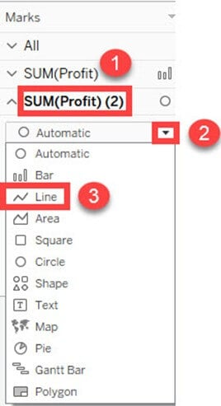

**Step 7)** Select ‘SUM(Profit)’ on the right side of rows as shown in the image.

1. Right click on it and select ‘Add Table Calculation’ from the list.

**Step 8)**It opens the Primary Calculation Type window.

1. Select ‘Running Total’ from the drop-down.
2. Select ‘Sum’ as aggregation from the drop-down.
3. Click on Compute Using ‘Table (across)’.
4. Check in the ‘Add Secondary Calculation’ box.
5. It expands the window for ‘Secondary Calculation Type’. Select ‘Percent of Total’ from the dropdown list.
6. Select on Compute Using ‘Table (across)’
7. Now close the Window by clicking on close icon as shown in the image.

**Step 9)** Go to the last marks card namely ‘SUM (Profit)’.

1. Click on color icon present in the marks card.

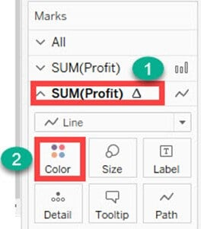

**Step 10)**Select any color of your choice.  
This changes the color of line present in the graph.

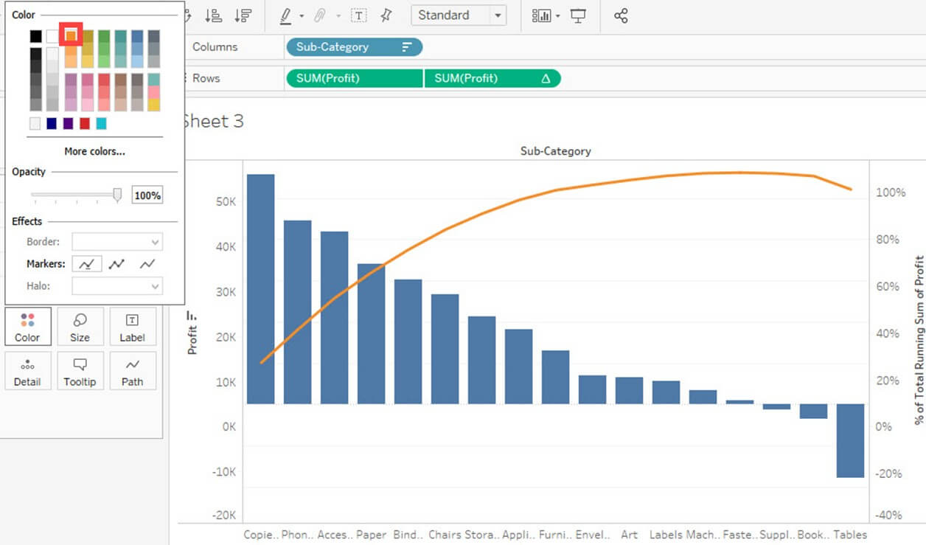

This is the procedure to create Pareto Chart in Tableau.

## Bullet Chart:

A bullet chart can be used as a gauge or indicator to show the performance of measures. Two measures can be compared to each other using the bullet graph. For example, if we are having estimated profit and actual profit we can compare both of them using bullet chart. The procedure to create bullet chart is given as follows.

**Step 1)**Go to a new Worksheet.

1. Click on ‘Analysis’ present in the Menu bar.
2. Select ‘Create Calculated Field’ from the list.

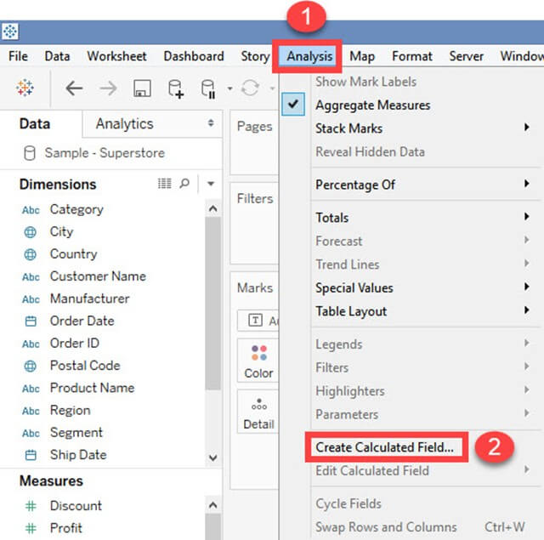

**Step 2)** It opens Calculated Field Window.

1. Enter a name for the calculated field. In this example, it is named as ‘Estimated Profit’.
2. Type the estimated value of the measure. In this example, Profit is taken as the measure. So the calculated field is created for estimated profit.
3. Click on OK.

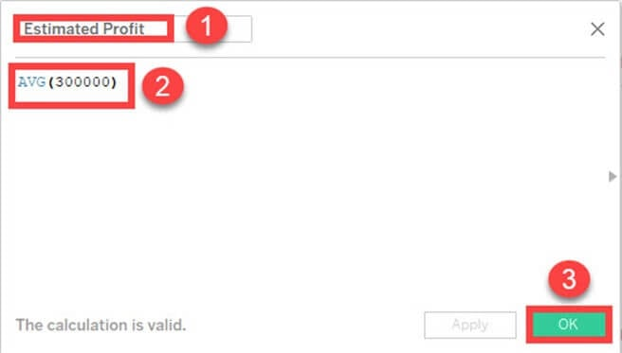

**Step 3)**Go to measures in Data pane. Hold the control key on keyboard and select ‘Estimated Profit’ and ‘Profit’.

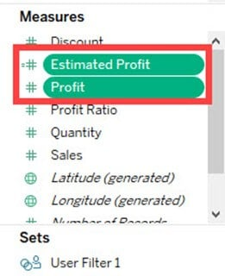

**Step 4)**

1. Click on ‘Show me’ button present in the top right corner of the worksheet.
2. Select bullet graph icon as shown in the image.

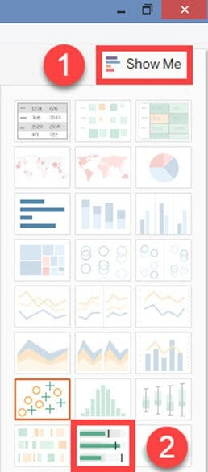

It creates a bullet graph as shown below.

## Bar Chart:

A bar chart can compare the data across different categories. The height of the bars represents the measured value of each category. It can be represented as vertical and horizontal type bar charts. The procedure to create bar chart is given as follows.

**Step)**Go to a new worksheet.

1. Drag ‘Category’ into Column.
2. Drag ‘Profit’ into Rows.
3. It creates a bar chart by default.

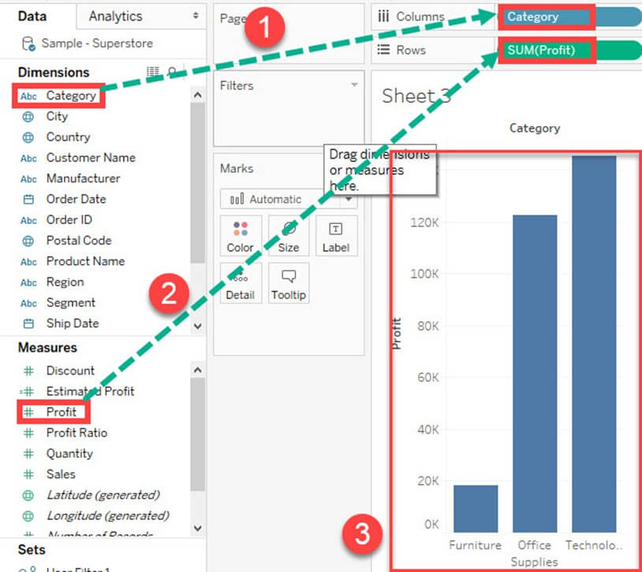

## Line chart:

A Line Chart should be used to compare the data over the different periods. A line chart is created by the series of dots. These dots represent the measured value in each period. The procedure to create line graph is shown below.

**Step)**Go to a new Worksheet.

1. Drag ‘Order Date’ into Columns.
2. Drag ‘Sales’ into Rows.
3. It creates a line chart by default.

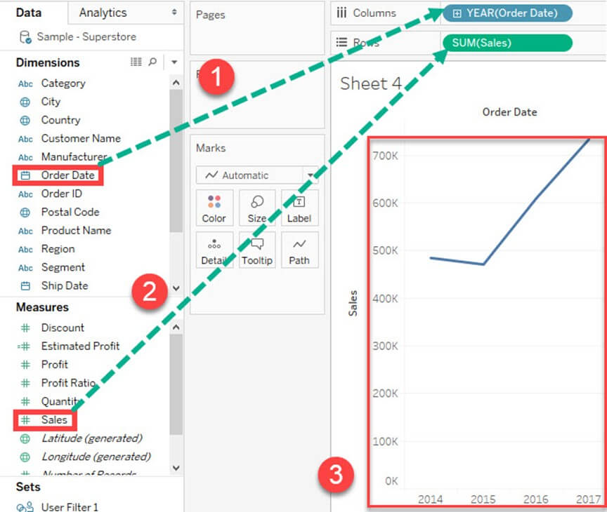

## Text Tables:

Text tables are used to show the exact value of measures across the different dimension. A text table is also called as a **Pivot Table**. It groups the dimensions and measures by default. The procedure to design a text table is given as follows.

**Step)**Go to a new Worksheet.

1. Drag ‘Sub-Category’ into Rows.
2. Drag ‘Profit’ into text box present in the marks card.
3. It creates a text table by default.

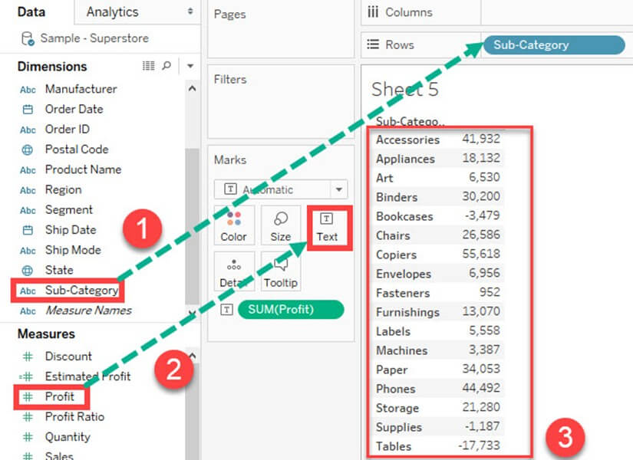

## Heat Map:

A heat map can visualize the data in the form of size as well as color on different measures. Two different measures can be visualized simultaneously using heat map. One measure can be assigned to size whereas another measure can be assigned to the color of the heat map. The procedure to create heat map is given as follows:

**Step 1)**Go to a new Worksheet.

1. Hold the control key on keyboard and select ‘Sub-Category’ and ‘Sales’ from the data pane.

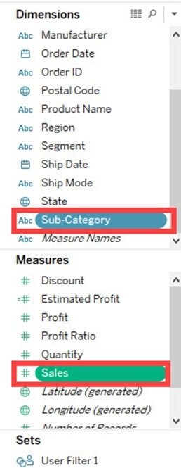

**Step 2)**

1. Click on the ‘Show me’ button present in the top right corner of the worksheet.
2. Select the ‘Heat Map’ icon as shown in the image.

**Step 3)**Drag ‘Profit’ into the Color box.

**Step 4)**

1. Drag ‘Region’ into Columns.
2. This will create a Heat map. It can be used to visualize Sales and Profit across different dimension.

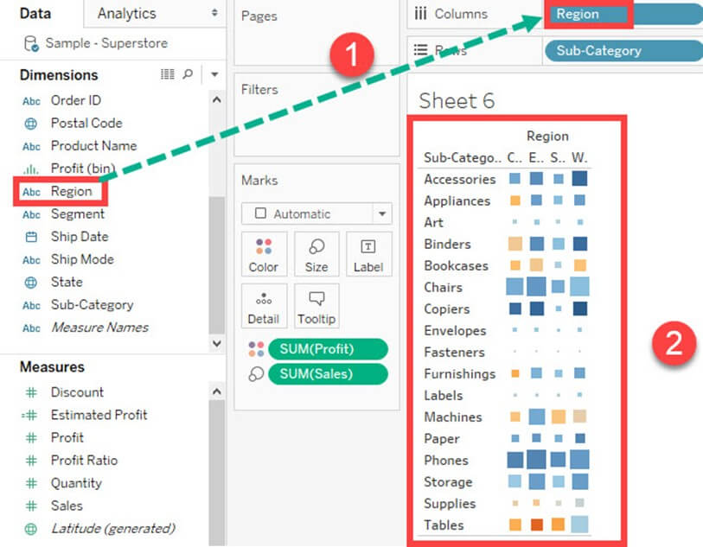

## Waterfall Chart:

Waterfall Chart can visualize the cumulative effect of a measure over dimension. It can show the contribution of growth or decline by each member in a dimension. For example, you can see the contribution of profit by each sub-category using a waterfall chart. The waterfall chart can be designed in Tableau by following the given procedures.

**Step 1)**Go to a new Worksheet.

1. Drag Sub-Category into Columns
2. Drag Profit into Rows.

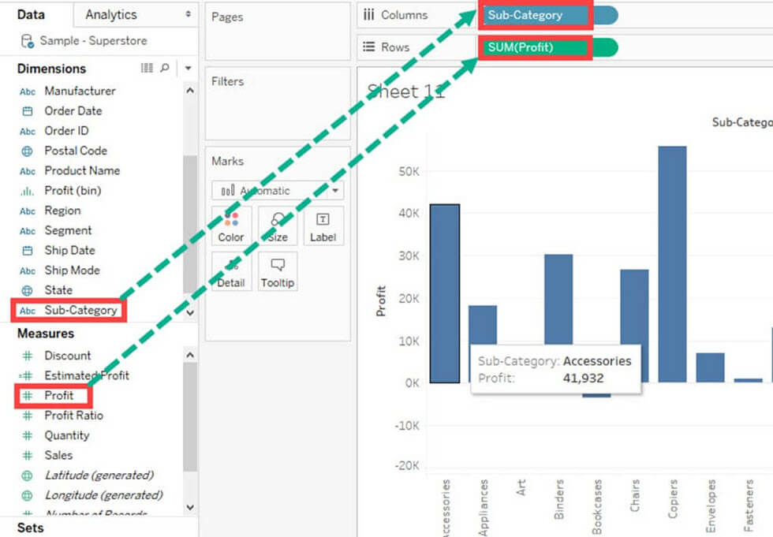

**Step 2)**

1. Right click on ‘Profit’ present in Measures Pane.
2. Choose ‘Create’ from the list.
3. Select the ‘Calculated Field’ Option.

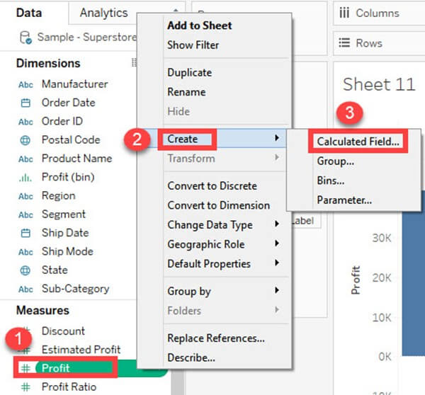

**Step 3)**It opens ‘Calculated Field’ Window.

1. Enter the name of the Calculated field as ‘-Profit.’
2. Write the formula as shown in the image.
3. Click on OK.

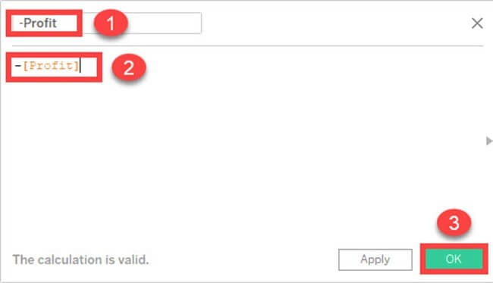

**Step 4)**Drag the newly created calculated field ‘-Profit’ into size option present in the marks card.

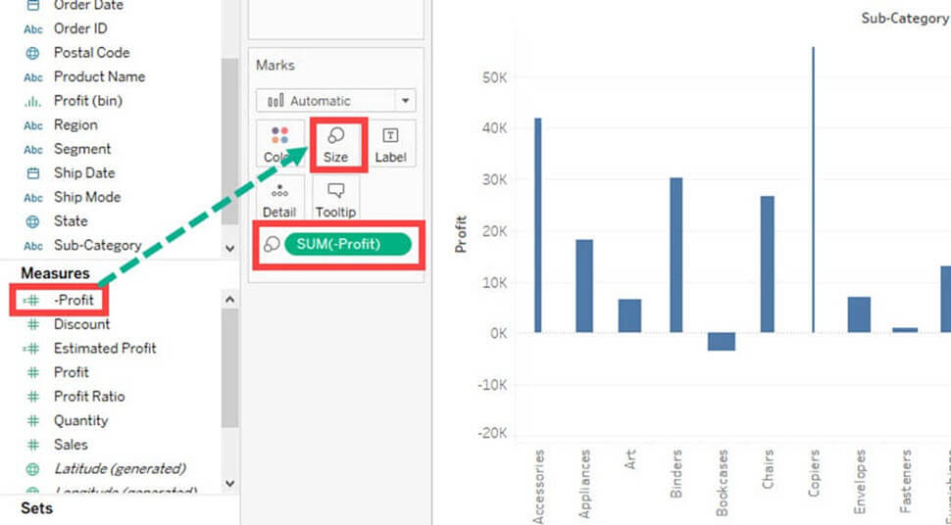

**Step 5)**

1. Right, Click on ‘SUM (Profit)’ present in the Rows.
2. Select ‘Quick Table Calculation’ from the list.
3. Click on ‘Running Total’ option.

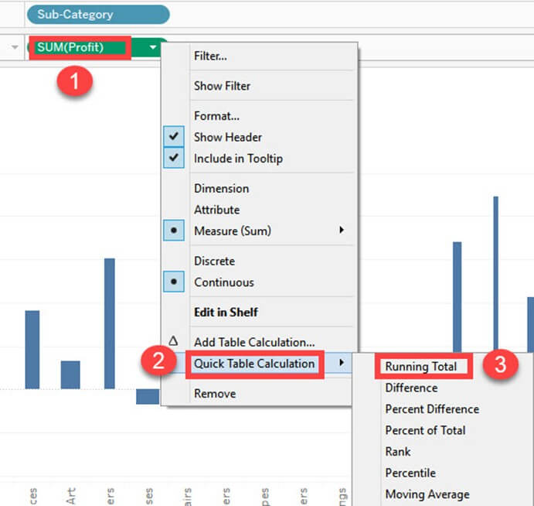

**Step 6)**

1. Click on the drop-down option present on the marks card.
2. Select ‘Gantt Chart’ from the list.

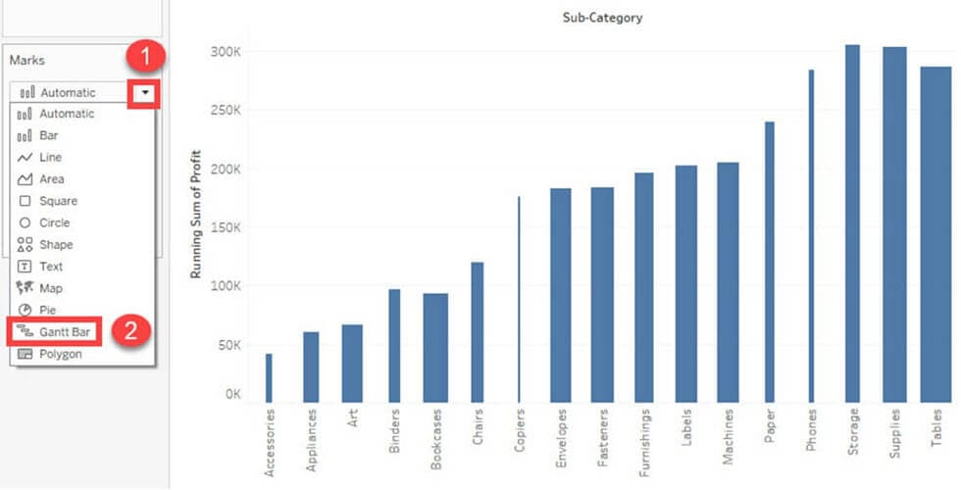

This creates a waterfall chart as shown below.

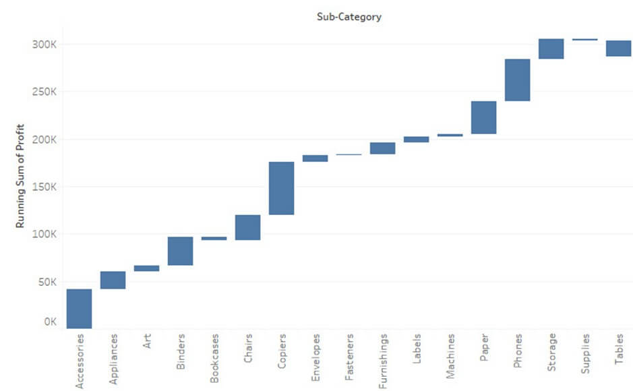

## Gantt chart:

A Gantt chart can show the comparison of data between categories. It can be used to identify the time taken for each process. In the below example, time taken for shipment by each type of ship mode is given. The procedure to create Gantt chart is given as follows.

**Step 1)**Go to a new Worksheet.

1. Click on the drop down button in Marks Card.
2. Select ‘Gantt Bar’ from the list.

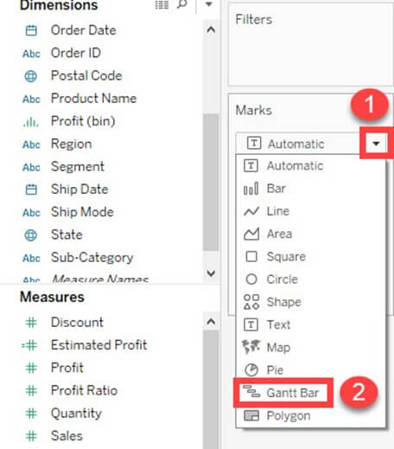

**Step 2)**

1. Drag ‘Order Date’ into Columns.
2. Right Click on the Order date and select the ‘Day’ as shown in the image.

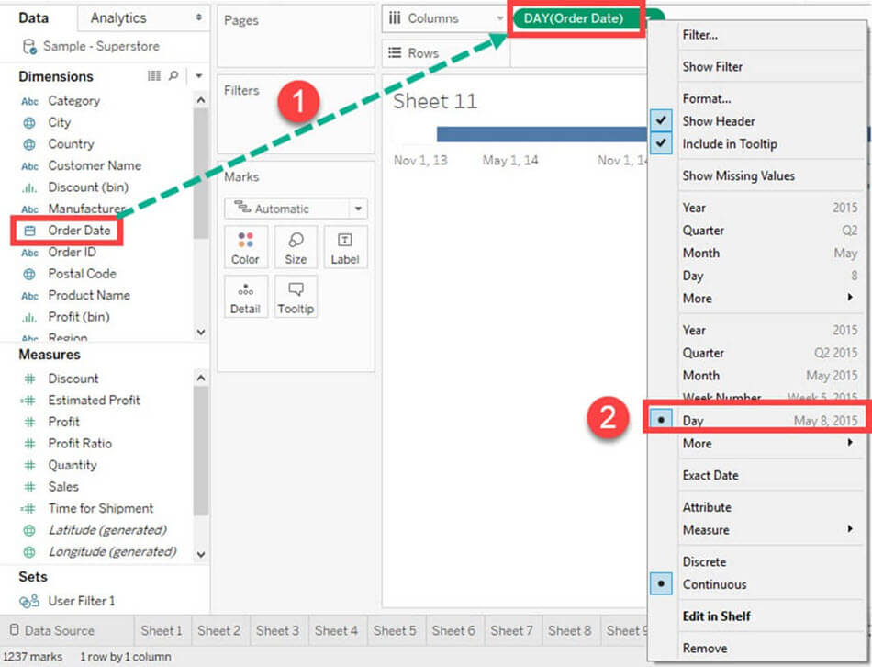

**Step 3)**

1. Click on ‘Analysis’ Present in Menu bar.
2. Select ‘Create Calculated Field’ present in the list.

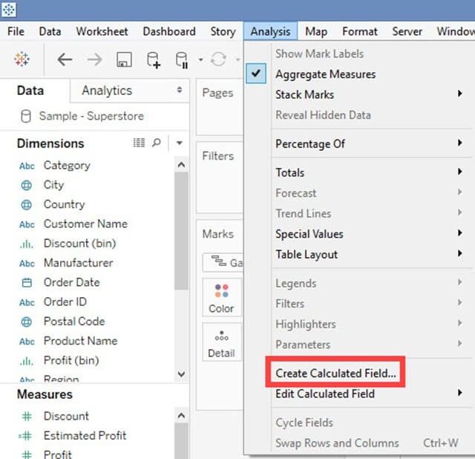

**Step 4)**

1. Enter the name of calculated field as ‘Time for Shipment’
2. Type the formula as shown in the image to create difference between order date and ship date.
3. Click on OK.

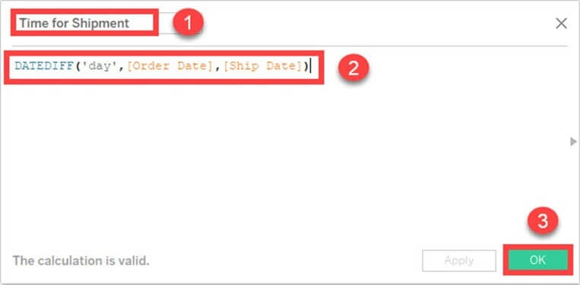

**Step 5)**

1. Drag ‘Ship Mode’ into Rows.
2. Drag ‘Time for Shipment’ into size icon present in the marks card.

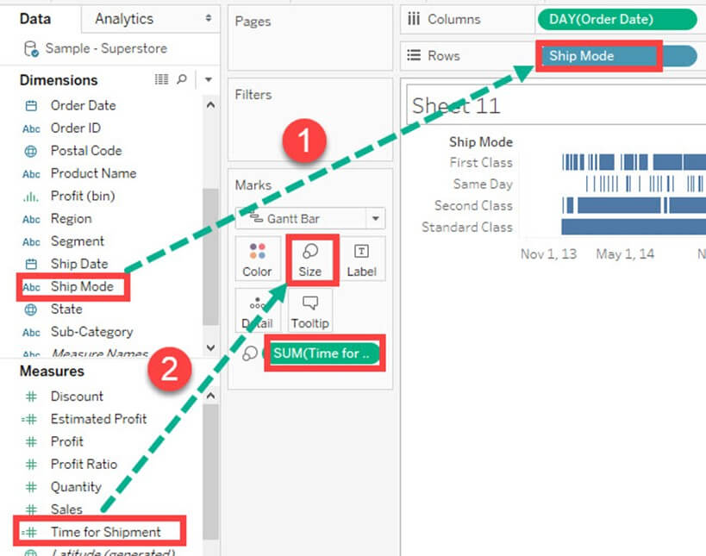

**Step 6)**This creates a Gantt chart. It shows the time taken for each shipment across different ship mode.

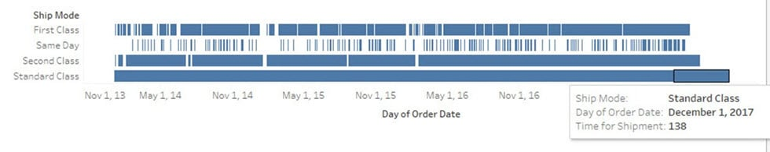

## Pie Chart:

A pie chart can show the segment-wise data. It can show the contribution of measure over different members in a dimension. The angle of pie determines the measured value. Different colors can be assigned to pie to represent the members in a dimension.

**Step 1)**Go to a new Worksheet

1. Select Segment and Sales from data pane.

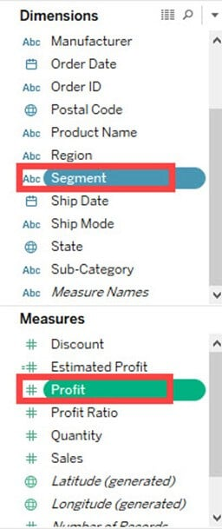

**Step 2)**

1. Click on ‘Show Me’ button present in the top right corner of the worksheet.
2. Select ‘Pie Chart’ from the list.

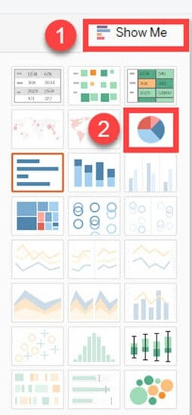

It creates a Pie Chart as shown below.

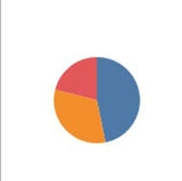

## Scatter Plot:

The relationship between two measures can be visualized using scatter plot. A scatter plot is designed by adding measures in both x and y-axis. This can show the trend or relationship between the measures selected. A scatter plot can be designed by following the below procedure.

**Step 1)**Go to a new Worksheet.

1. Drag ‘Discount’ into Columns.
2. Drag ‘Sales’ into Rows.

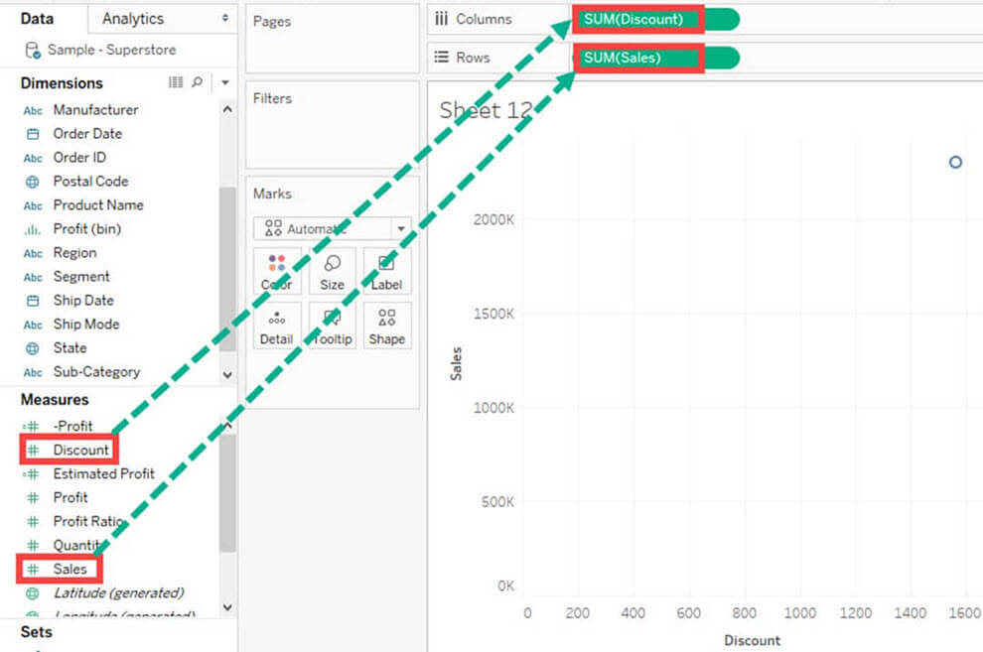

This creates a scatter plot by default.

**Step 2)**

1. Drag ‘Sub-Category’ into Color icon present in the Marks card.
2. It creates a scatter plot showing the relationship between discount and sales for each sub-category.

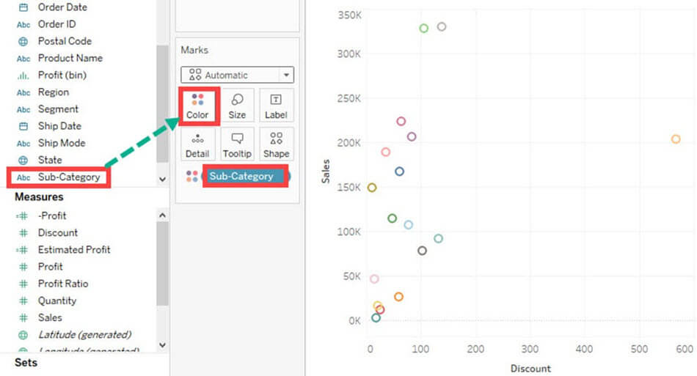

## Area Chart:

Area chart can represent any quantitative (measure) data over different period of time. It is basically a line graph where the area between line and axis is generally filled with color. The procedure to create area chart is given below.

**Step 1)**Go to a new Worksheet.

1. Hold the control key on keyboard and select ‘Order Date’ and ‘Quantity’.

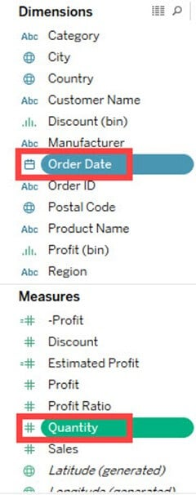

**Step 2)**

1. Click on ‘Show Me’ option present at the top right corner of the worksheet.
2. Select the Area chart icon as shown in the figure.

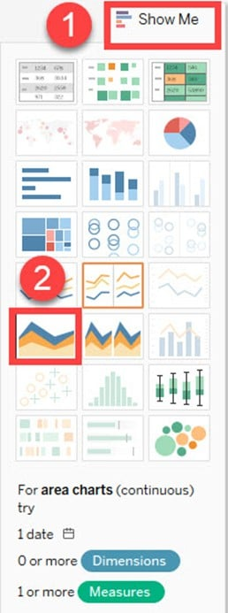

**Step 3)**

1. Drag ‘Region’ from dimension pane and add it in color icon of Marks card.
2. This creates an area chart as shown in the image.

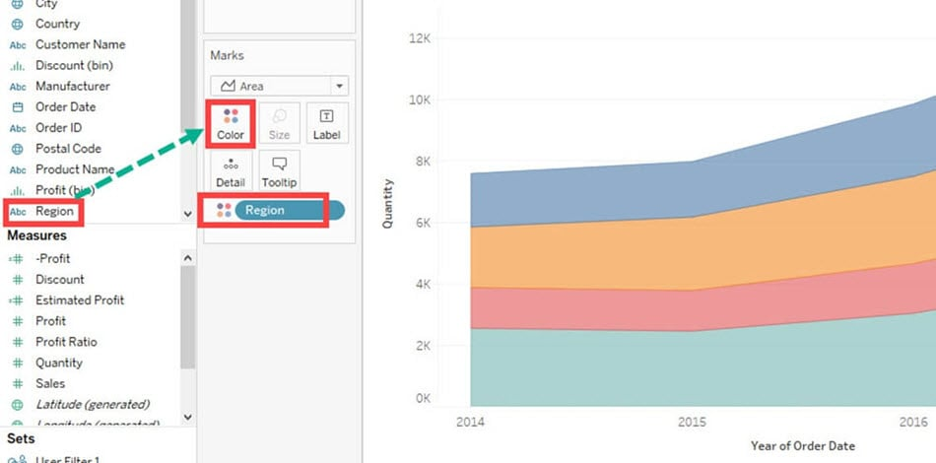

## Dual Axis Chart:

Dual axis chart can be used to visualize two different measures in two different chart types. A date column and two measures are necessary to build a dual axis chart. The different scales used in the graph helps the user to understand both measures. The procedure to create dual axis chart is shown below.

**Step 1)**Go to a new Worksheet.

1. Hold the control key and select ‘Order Date’, ‘Sales’ and ‘Quantity’.

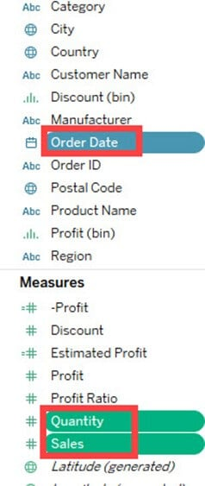

**Step 2)**

1. Click on ‘Show Me’ option present in the top right corner of Worksheet.
2. Select ‘dual combination’ icon as shown in the image.

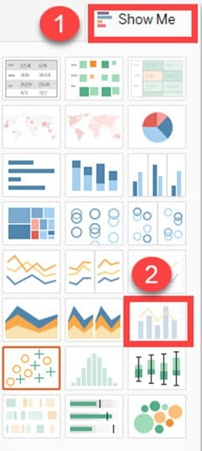

It creates a dual axis chart as shown in the figure.

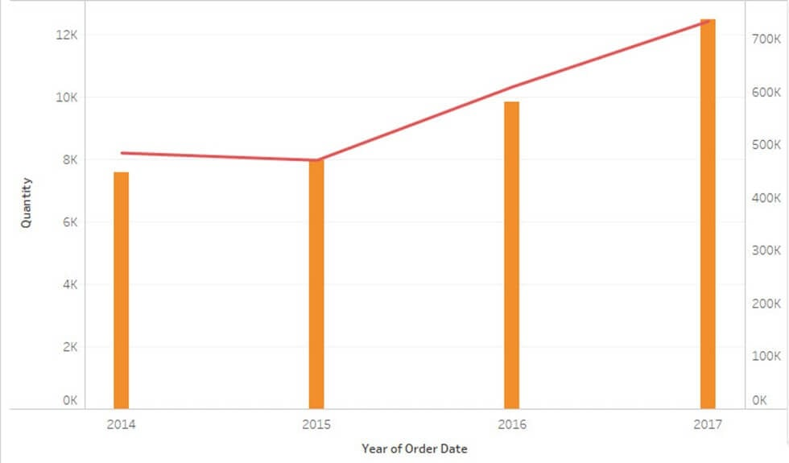

## Bubble Chart:

A bubble chart visualizes the measures and dimensions in the form of bubbles. The sizes of the bubbles determine the size of measure value for effective visualization. The color of bubbles can be set to differentiate the members present in a dimension. The procedure to create bubble chart is given below.

**Step 1)**Go to a new Worksheet.

1. Hold on the Control key in the keyboard.
2. Click on ‘Sub-Category’ and ‘Sales’.

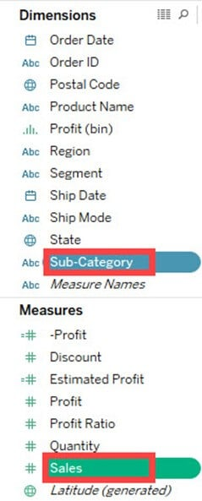

**Step 2)**

1. Click on the ‘Show Me’ option present in the top right corner of the worksheet.
2. Select the ‘Packed bubbles’ icon as shown in the image.

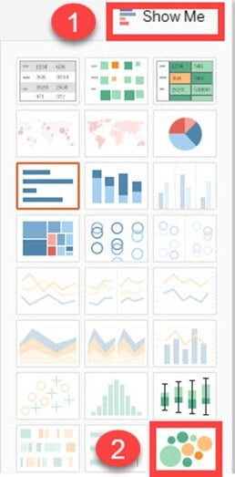

It creates a bubble chart as shown below

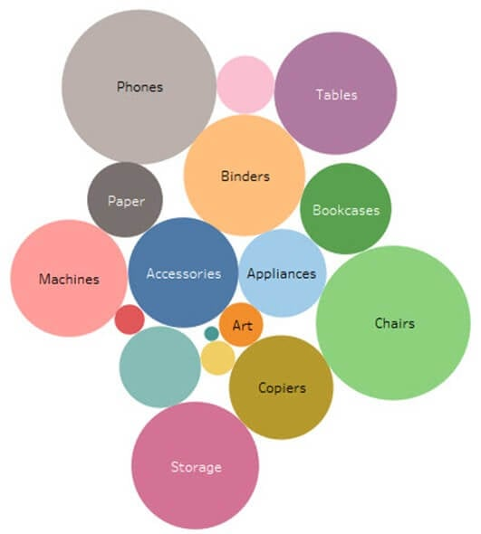

## Histogram:

A histogram can show the values present in a measure and its frequency. It shows the distribution of numerical data. As it shows both frequency and measure value by default, it can be useful in many cases. For example, if you want to analyze the discount given by a retail shop, you can visualize the amount of discount and its frequency using histogram. The procedure to create histogram is shown below.

**Step 1)** Go to a new Worksheet.

1. Select ‘Discount’ from the measures.

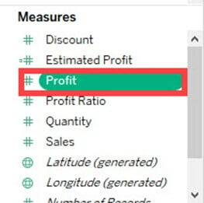

**Step 2)**

1. Click on ‘Show Me’ button present in the top right corner of the worksheet.
2. Select the ‘Histogram’ icon as shown in the image.

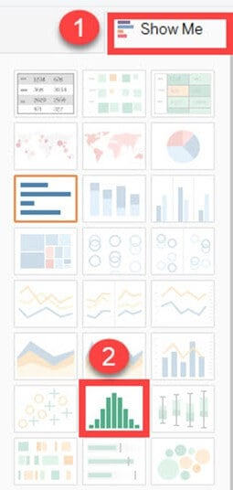

It creates a histogram chart in Tableau.

